ABQ Ride
ADA Compliance Assessment
December 2008
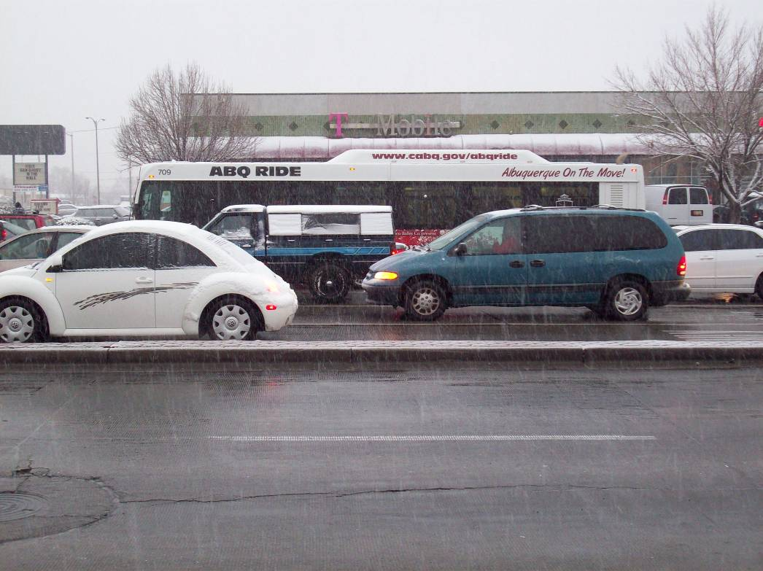

Conducted by:


ABQ Ride 2008 ADA Assessment Report
1. Introduction
On December 15 through 17, 2008, representatives of Delta Services Group, Inc. conducted a covert Americans with Disabilities Act (ADA) compliance assessment of the Albuquerque fixed route public transit system. The is the second such assessment conducted in 2008, following a similar study in August. What follows is an overview of how this assessment was conducted, and a report of the results of this effort.

1.1 The ABQ Ride Bus System
ABQ Ride is the public transit provider in the greater Albuquerque area. It is a department of the City government and operates traditional fixed route, express bus or Bus Rapid Transit (BRT), operated on Rapid Ride routes # 766 & #790, and paratransit (Sun Van). The bus system operates 37 routes during weekdays and 22 routes on weekends (some of these do not operate on Sunday). There are four types of transit coaches operated in the ABQ ride system:

New Flyer low-floor transit coaches equipped with automated annunciator systems to provide stop announcements. (below).
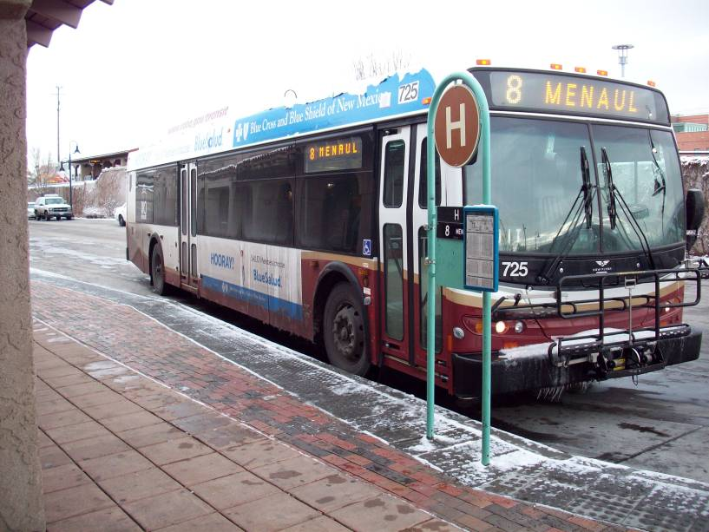
Neoplan brand full size transit coaches, most equipped with front door stairwell lifts, kneelers and automated enunciators for stop announcements (below).
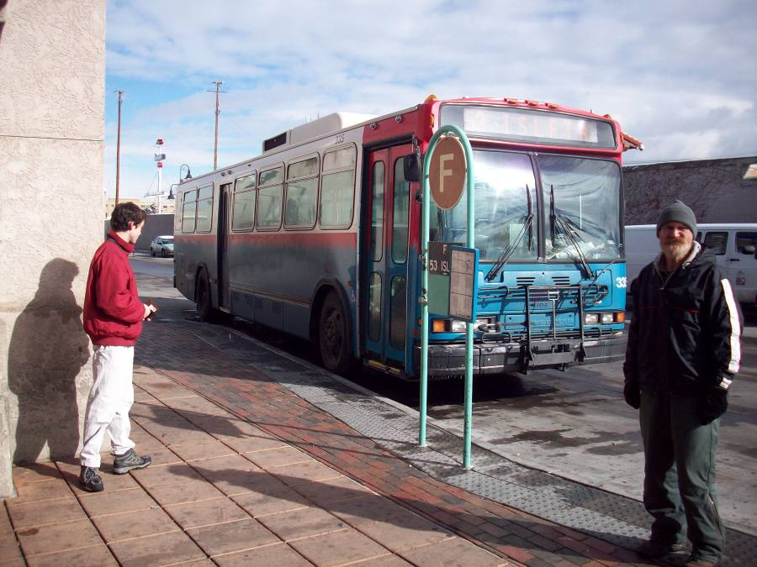
Thomas mid-sized, low floor, fully accessible transit coaches, equipped with front door ramps, kneelers and automated stop enunciators (below).
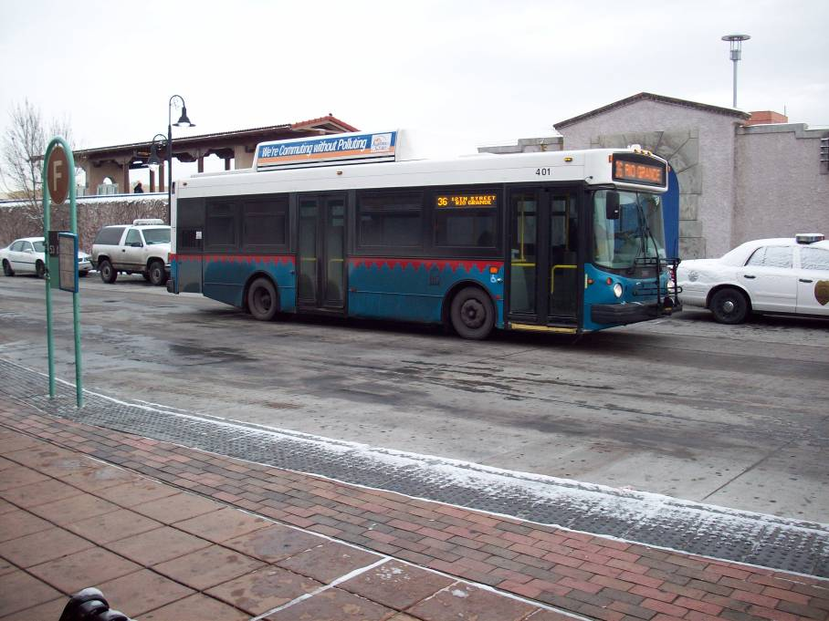

New Flyer Articulated low floor transit coaches (operated on Rapid Ride BRT route) equipped with front door ramps, kneelers and automated stop enunciators (below).
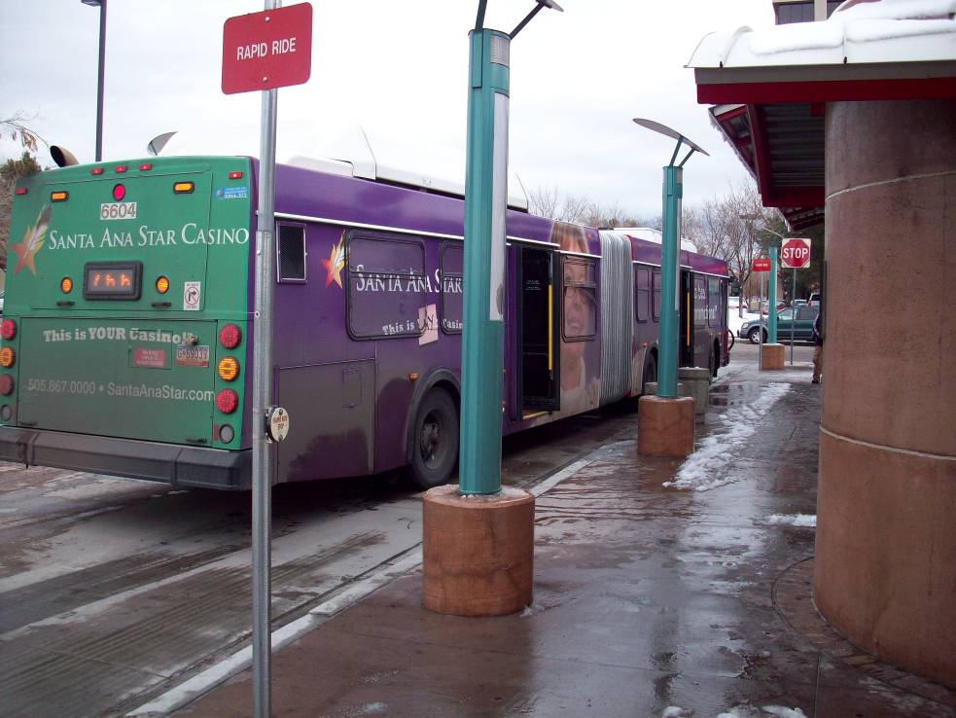

The majority of ABQ Ride’s regular and commuter routes are served by a mixture of New Flyer low floor and Neoplan buses, affording full accessibility to every route in the system. The smaller Blue Bird mid-sized buses are used on lower capacity routes, many of the peak or rush-hour only routes and for the downtown circulator. The articulated New Flyer coaches are used exclusively on the #766 (Red Line) and #790 (Blue Line) bus rapid transit (BRT) routes.
In addition to a fully accessible bus fleet that affords accessibility to all routes, the ABQ Ride system also has an impressive accessible bus stop infrastructure. Throughout the system, Delta encountered a good distribution of bus stop signs that were easy to spot and generally up to date, many bus stops were improved sites with concrete bus stop pads, benches and even shelters, and an excellent network of sidewalks and curb cuts throughout the city. The photos below depict a typical bus stop and its amenities.
This typical stop provides paved access to the bus from the sidewalk, a bench, a yellow curb restricting parking or standing and a sign indicating the route serving the stop. The photo below shows a raised type and Braille medallion affixed to the bus stop sign. These were present at most stops.
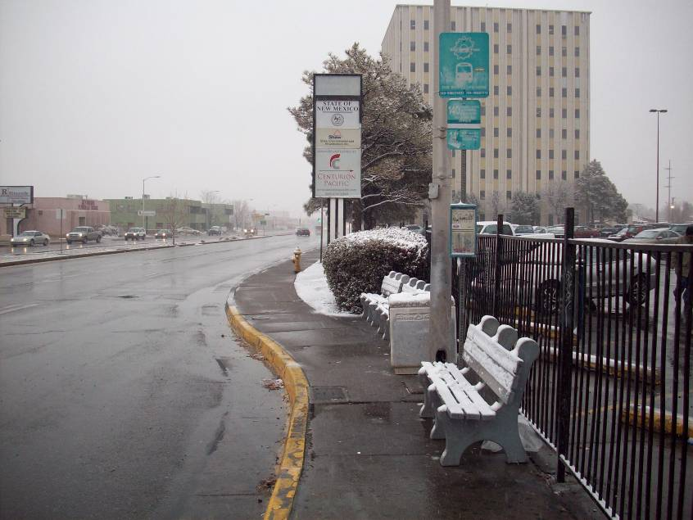
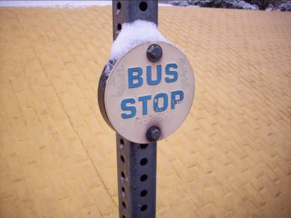

The accessibility of the streetscape and bus stops in Albuquerque are among the best we have seen anywhere in the country. This streetscape, combined with the favorable topography of Albuquerque, makes for a city and fixed route bus system that is very navigable and accessible for many passengers with disabilities.

2. Assessment

2.1 Scope of the Assessment
During our on-site assessment, Delta conducted 91 covert observations of fixed route bus operations. These observations were confined to local fixed routes and Albuquerque’s two Bus Rapid Transit (BRT) routes, the 766 and 790. Delta rode buses and made observations in a manner that would not indicate to the driver that he/she was being observed. In most cases, we believe that drivers had no idea they were being observed.
We employed a quasi random approach to sampling routes, typically selecting a route originating from the Alvarado Transportation Center (ATC) or somewhere in the downtown area and then branching out and connecting to other intersecting routes. We made no attempt to concentrate on, or to avoid, any particular route, with the exception of Morning and afternoon peak or express routes which only operated a handful of times each day. We also were unable to sample several routes and/or made few rides on some routes with extended headways and limited connections with other routes due to the very limited time period of the study and the objective of at least 80 observations during the period. The table below indicates the distribution of observations among the regular ABQ Ride daily routes.
Table 1: Distribution of Observations Per Bus Route
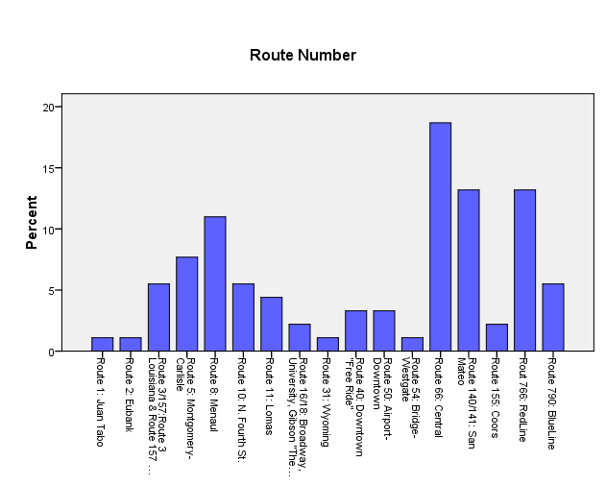
Delta conducted 18 hours and 47 minutes of actual deployed field observations, with a mean ride time of 12 minutes and a median ride time of 11 minutes. Our observations were well distributed among the different bus types in the ABQ fleet, as the table below indicates:

Table 2: Distribution of Observations Per Bus Class
ABQRide Bus Numbers | Manufacturer | Automatic Announcement System | Frequency
300 Series | Neoplan | DR500 | 28
400 Series | Thomas | DR600 | 9
700 Series | New Flyer | DR600 | 35
6400 Series | New Flyer | DR600 | 9
6600 Series | New Flyer | DR600 | 6

In the appendix to this report, we provide a full listing of the coach numbers of every bus we rode during the survey period and the frequency with which we rode it.
While we employed a method of selecting routes for observation that was not intended to sample any given route more or less than others, it is important to note that this was not a true random sampling of bus routes. Furthermore, though a sample of 91 runs is of reasonable size for a study of this type, this is not a sample large enough or gathered over a sufficiently broad period of time to yield statistically valid results which are representative of a passenger’s likely experience riding the ABQ ride system. The results presented here are an analysis of the data we collected and are not meant to represent a scientifically valid cross section of the overall performance of the ABQ Ride system. However, the strength of some of these results would seem to indicate that they are reasonably representative of a typical experience by riders. In any case, this information is intended to provide ABQ Ride with a basis for further study and investigation; it is not a definitive, scientifically valid profile of the current service.

2.2 Findings: Stop Announcements
The assessment was primarily designed to determine how well the City of Albuquerque’s ABQ Ride system is complying with the stop announcement requirements of the Americans with Disabilities Act (ADA). As a reference, we have provided a citation of the applicable ADA regulations in this area, promulgated by the US Department of Transportation:

Code of Federal Regulations, Title 49, Volume 1, Revised as of October 1, 2005 [CITE: 49CFR37.167]
TITLE 49—TRANSPORTATION, Subtitle A--Office of the Secretary of Transportation
PART 37, TRANSPORTATION SERVICES FOR INDIVIDUALS WITH DISABILITIES (ADA)
Subpart G, Provision of Service, Sec. 37.167 Other service requirements.

- This section applies to public and private entities.

(b) On fixed route systems, the entity shall announce stops as follows:

(1) The entity shall announce at least at transfer points with other fixed routes, other major intersections and destination points, and intervals along a route sufficient to permit individuals with visual impairments or other disabilities to be oriented to their location.

(2) The entity shall announce any stop on request of an individual with a disability.

(c) Where vehicles or other conveyances for more than one route serve the same stop, the entity shall provide a means by which an individual with a visual impairment or other disability can identify the proper vehicle to enter or be identified to the vehicle operator as a person seeking a ride on a particular route.

To satisfy these requirements, the bus system must have an auditory means of announcing the required points along the route, which we have called “Wayfinding Announcements,” since these help passengers remain oriented as they travel on the bus and enable them to find their way along the system. Obviously, the second type of required announcement is one provided upon request of passengers. The third is an auditory means, heard outside of the bus, by which passengers can distinguish what bus has pulled to the curb at locations where more than one bus serves a particular stop.
The ABQ Ride system employs automated annunciators on every bus to make these announcements. These annunciators are loaded with information specific to each route, which enables them to make announcements based on a variety of sensor inputs, such as odometer readings, an internal clock, Geographical Positioning System (GPS) receiver input and bus passenger door activation. These systems are designed to make two types of announcements; wayfinding announcements and route identifier announcements. The wayfinding announcements are made as the bus travels along the route and the sensors indicate the approach of one of the programmed waypoints. The announcements are made on overhead speakers installed in the ceilings of the buses. The route identifier announcements are made when the front doors of the bus are opened and are usually broadcast through speakers just inside the doors or on speakers outside and above the front entrance door (depending on the model of the bus). These route identifier announcements are made in a manner that they are intended to be heard outside of the bus by passengers waiting at the bus stop. In addition to these automated systems, each bus is also equipped with a powered public address system which the drivers can use in the event of a malfunction of the automated system.
As this is a report that assessed the same variables as those assessed in August 2008, we are providing the results of both studies below to show the trend of improvement

2.2.1 Wayfinding Announcements:
The first observation we made was whether wayfinding announcements were being made and, if so, how they were being made. Our results are indicated below:
Table 3: Type of Announcement (Primary)
Type of Announcement | Frequency | Percent (%) | Aug ‘08
Automated Annunciator | 87 | 95.6 | 87.4
PA System (Microphone for Driver) | 1 | 1.1 | 1.9
Non amplified voice | 2 | 2.2 | 0
No Announcement Observed | 1 | 1.1 | 8.1
Total: | 91 | 100.0 | 100.0

We found that, in the vast majority of instances, wayfinding announcements were made using the automated annunciator. In the 4 cases where the automated annunciator was not working, drivers either used the PA system or simply called out the stops with their voice.
In addition to the primary means of making announcements, we also noted whether drivers also made announcements that supplemented the automated system. This was noted in 6 cases, three of which used a microphone and 3 of which the driver simply called out in his/her voice.
In addition to the question of whether and how announcements were made, we also noted the quality of these announcements. In our work throughout the country, we have noted instances where automated systems are making announcements, yet the volume level or audible quality of these announcements was such that they were not easy to understand. In the case of ABQ Ride, we noted the following concerning the quality of wayfinding announcements:
Table 4: Announcement Quality
Quality | Frequency | Percent (%) | Aug ‘08
Loud and Clear throughout bus | 88 | 96.7 | 81.8
Understandable but volume too low; difficult to hear throughout the bus | 1 | 1.1 | 13.1
Loud but Garbled; difficult to understand | 1 | 1.1 | 3.0
Low Volume and Garbled; not understandable | 1 | 1.1 | 2.0
Total | 91 | 100.0 | 100.0

In Albuquerque, we found that the quality of announcements was generally very good. In just over 2% of cases was quality less than optimal and in only 1 case was the quality such that it was difficult to understand. These measures are significantly improved from August 2008. The distribution of announcement quality issues was equally distributed between bus types.

2.2.2 Requested Stop Announcements
During the survey period, we listened for passengers requesting announcements and noted the extent to which these announcement requests were executed. For whatever reason, we rarely observed passengers requesting stops.
Table 5: Requested Announcements
Were stops announced on request? | Frequency | Percent (%) | Aug ‘08
Never | 1 | 20.0 | 33.3
Always | 4 | 80.0 | 66.7
Total | 5 | 100.0 | 100.0

Of the five requests observed, four were honored. Generally, it is clear that the frequency of the wayfinding announcements makes it unnecessary for passengers to request stop announcements.

2.2.3 Bus Identification Announcements
The third type of announcement we observed were bus identification announcements. As indicated earlier, these were made when buses stopped at a particular location and opened their doors. In this category, ABQ Ride performed well.
Responses to this variable were very positive and indicated an improvement over the August study. The results are provided below.
Table 6: August 2008 External Announcements*
Were External Announcements Audible? | Frequency | Percent (%)  Dec ‘08 | Percent (%)  Aug ‘08
Always | 85 | 93.4 | 38.0
Usually | 3 | 3.3 | 22.0
Sometimes | 0 | 0.0 | 12.0
Never | 3 | 3.3 | 28.0
Total | 91 | 100.0 | 100.0
*No record was made in 11 cases in August due to a hurried boarding process or overcrowding.

The variable “usually” refers to instances where the announcements were typically made as required and expected, yet inexplicably, there were instances when the bus stopped, the doors opened and the bus did not make an announcement. This is difficult to explain because the sole trigger for this type of announcement is the cycling of the front passenger doors. Most likely, this indicates some type of problem with the announcement system hardware.
In addition to noting whether bus identification announcements were made, we added a new variable to the December study to measure the quality of these announcements. The results of this measure are provided below:
Table 7: Quality of External Announcements
Were External Announcements Audible? | Frequency | Percent (%)
Loud and clear | 87 | 95.6
Clear but volume too low | 1 | 1.1
Loud but garbled | 0 | 0.0
No curb announcements made | 3 | 3.3
Total | 91 | 100.0

Overwhelmingly, this area has improved. Although we did not formally measure this in August, we noted many instances where the announcements were being made but that they were hard to hear or understand. This problem has clearly been fixed. It is noteworthy that 3 of the 4 problem observations noted in this area occurred on the 766 bus route.

2.2.4 Stop Announcement Overall Summary
Generally, a passenger riding an ABQ Ride fixed route bus can expect to encounter buses that make frequent announcements almost all of the time. Announcements both identifying the bus at the curb (93%) and wayfinding announcements aboard the bus (96%) are almost always made. These announcements are typically clear at least 96% of the time. This is a significant improvement from August of 2008.

2.2.5 Longitudinal Comparisons
This assessment was Delta’s fourth assessment in three years. Although the first two assessments were not primarily focused on stop announcements, they did collect data in these areas. Unfortunately, the 2006 and 2007 studies asked less specific questions about stop announcements and therefore, results for identical variables can’t be compared year to year. For example, only in 2008 did we specifically observe external announcements aimed at passengers waiting at the curb. Previous to this, we mainly concentrated on what we have called “wayfinding announcements” which are announcements that can be heard aboard the bus. The table below compares each year’s percentage of completed wayfinding announcements by bus type for the three years of our observations:
Table 8: Percentage of correct wayfinding announcements by bus type.
 | RTS/NOVA | Neoplan | Low Floor | Articulated
2006 | 4% | 48% | 90% | 56%
2007 | 26% | 87% | 90% | 100%
2008 August* | n/a** | 91.4% | 92% | 85%
2008 December | n/a** | 100% | 99% | 97%
* Includes both automated and manual announcements. **All RTS buses were retired in 2008.
The above statistics clearly show a positive trend, with the largest improvement resulting from the retirement of the entire RTS/NOVA fleet and their replacement with New Flyer low floor coaches with installed stop annunciators. Although there was a slight degradation compliance with articulated buses in August 2008, this has again improved in this study. These data indicate that ABQ Ride continues to improve.

2.3 Incidental Observations
During the course of the study, ABQ Ride asked that Delta observe a number of other aspects of the performance of their system if and when they were incidentally encountered while we were out riding buses. Our report of these incidental observations is provided below.

2.3.1 Service Provided to Passengers with Disabilities
During the survey period, we observed only 4 passengers with disabilities (PWD) boarding, riding in or alighting ABQ Ride Buses. These were incidental observations which occurred as we were riding buses monitoring stop announcements. We never were able to observe the entire process of a passenger boarding and alighting a bus. We typically observed a portion of this process and made observations as we could for the portion of the process observed.
The number of passengers with disabilities observed during this assessment was surprisingly low and was less than half of what we have observed during similar assessments in the past. We speculate that this was due to the weather. As can be seen from the photographs provided in this report, the survey was conducted during a period of adverse winter weather. On the first day of the study, December 15th, it snowed a good portion of the day and this likely affected ridership. The second day of the study was cold and, though it did not snow further, there were many media reports of travel problems relating to the adverse weather from the day before.
As a reference, the relevant portions of the regulations governing what is required when transporting passengers with disabilities are summarized in the regulatory citation below:
Code of Federal Regulations, Title 49, Volume 1, Revised as of October 1, 2005
TITLE 49—TRANSPORTATION, Subtitle A--Office of the Secretary of Transportation
PART 37, TRANSPORTATION SERVICES FOR INDIVIDUALS WITH DISABILITIES (ADA)
Subpart G, Provision of Service

Sec. 37.165 Lift and securement use.

(a) This section applies to public and private entities.

(b) All common wheelchairs and their users shall be transported in the entity's vehicles or other conveyances. The entity is not required to permit wheelchairs to ride in places other than designated securement locations in the vehicle, where such locations exist.

(c)(1) For vehicles complying with part 38 of this title, the entity shall use the securement system to secure wheelchairs as provided in that Part.

(2) For other vehicles transporting individuals who use wheelchairs, the entity shall provide and use a securement system to ensure that the wheelchair remains within the securement area.

(3) The entity may require that an individual permit his or her wheelchair to be secured.

(d) The entity may not deny transportation to a wheelchair or its user on the ground that the device cannot be secured or restrained satisfactorily by the vehicle's securement system.

(e) The entity may recommend to a user of a wheelchair that the individual transfer to a vehicle seat. The entity may not require the individual to transfer.

(f) Where necessary or upon request, the entity's personnel shall assist individuals with disabilities with the use of securement systems, ramps and lifts. If it is necessary for the personnel to leave their seats to provide this assistance, they shall do so.

Sec. 37.167 Other service requirements.

(e) The entity shall ensure that vehicle operators and other personnel make use of accessibility-related equipment or features required by part 38 of this title.

(g) The entity shall not refuse to permit a passenger who uses a lift to disembark from a vehicle at any designated stop, unless the lift cannot be deployed, the lift will be damaged if it is deployed, or temporary conditions at the stop, not under the control of the entity, preclude the safe use of the stop by all passengers.

(i) The entity shall ensure that adequate time is provided to allow individuals with disabilities to complete boarding or disembarking from the vehicle.

(j)(1) When an individual with a disability enters a vehicle, and because of a disability, the individual needs to sit in a seat or occupy a wheelchair securement location, the entity shall ask the following persons to move in order to allow the individual with a disability to occupy the seat or securement location:

(i) Individuals, except other individuals with a disability or elderly persons, sitting in a location designated as priority seating for elderly and handicapped persons (or other seat as necessary);

(ii) Individuals sitting in or a fold-down or other movable seat in a wheelchair securement location.

(3) The entity is not required to enforce the request that other passengers move from priority seating areas or wheelchair securement locations.

As stated earlier, Delta observed 4 passengers with disabilities during the 3 calendar days on which we made observations. To record the required steps of the boarding, securement and alighting process, Delta used a modified version of a survey instrument developed and refined to make similar observations in Boston and Detroit. This instrument was developed to assess transit system compliance with ADA requirements necessary to evaluate system compliance with ADA lawsuit settlements in place in both cities. A copy of this instrument is provided in the appendix of this report and a summary of the observations we made is provided below.

2.3.1.1 Dates and locations of observations
Of the observations with PWD's, 3 were on the first day of observations and 1 was on the second day. The bus routes where we observed the PWD's are listed in Table 9. The buses on which we observed PWD's are listed in Table 10.
Table 9: Routes with observed PWD
Route | Frequency | Date
140/141 North | 1 | 12/15
66 West | 1 | 12/15
766 West | 1 | 12/15
140/141 North | 1 | 12/16
Total | 4 | 100.0

2.3.1.2 Buses where observations made
The following table indicates the actual coach numbers of the buses on which we observed passengers with disabilities. The table after that breaks these observations down by bus type.

Table 10: Bus Numbers with observed PWD
Bus Number | Bus Type | Date | Time
337 | Lift | 12/15 | 8:12 am
742 | Low Floor | 12/15 | 10:40 am
6407 | Artic. | 12/15 | 11:40 am
302 | Lift | 12/16 | 11:41 am

2.3.1.3 Pulling to the Curb and Boarding
In every observation of a Passenger with a Disability (PWD) in a wheel chair or scooter, the driver pulled within one foot of the curb (4 out of 4, 100%) and used the ramp or lift without having to be asked. Also, the drivers operated the lifts without any problems.
Buses never encountered obstructed curbs at the bus stop, therefore we have no observations about how the driver handled an obstructed bus stop.
Drivers offered kneelers without request 2 of 2 times when they were needed. Drivers offered the ramp without request 2 of 2 times. Drivers also seemed able to operate equipment proficiently, using the power ramp and the power lift without a problem. Where we observed passengers boarding, drivers also waited for the PWD to board the lift without rushing them 4 of 4 times.

2.3.1.4 Bus Driver Attitude
There were several points throughout the observation where we noted the attitude of the Bus Driver. We used a two choice scale for this observation:
- Business-Like, or
- Unpleasant

During the 4 instances where drivers were assisting passengers with disabilities, drivers were businesslike all of the time.

2.3.1.5 Asking Non Disabled Passengers to Move and Crowding
None of the observations occurred where buses were overcrowded so accommodating the passenger with a disability was never a problem.

2.3.1.6 Securing the Mobility Device
When possible, we observed the process of securing passengers’ scooters and wheelchairs using the installed securement systems. The ABQ Ride system uses the common “four point” securement system, in which wheelchairs are secured by means of retractable or adjustable belts that can be attached to the four corners of the wheelchair’s frame and then to hard points on the bus floor or seat frames.
When noting the number of securement straps typically used, we noted that 2 straps of the 4 available were used. Of the 4 times we observed a wheel chair or scooter, only 2 straps were used to secure wheelchairs in every case. In no instances did we note the proper use of 4 straps. Additionally, these straps were not usually secured properly.
In the picture below, a PWD can be seen riding in the securement area of a lift coach with only the rear wheels of the wheelchair secured. This photo was taken covertly by a Delta observer.
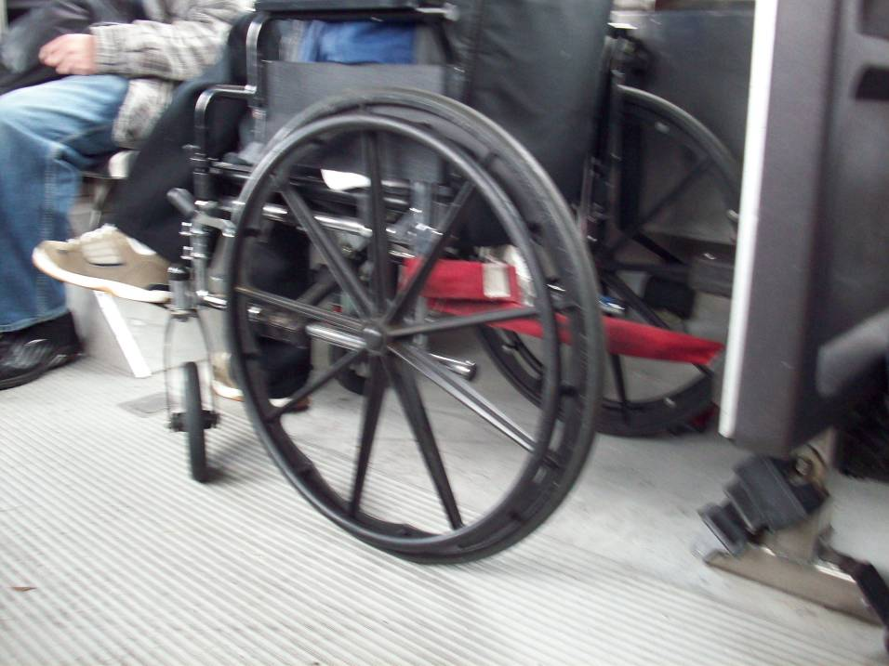

2.3.1.7 Lap and Shoulder Belts
Although we noted that lap and shoulder belts appeared to be installed on all of the buses where we made our observations, they were never offered by drivers nor requested by passengers. This is again troubling, as this important piece of safety equipment should be offered to passengers riding in secured wheelchairs.

2.3.1.8 Overall Summary of Service to Passengers with Disabilities
It is important to note that our observations of service to passengers with disabilities represented an extremely small sample and yielded results that were in no way statistically significant or scientifically representative of typical service likely to be encountered by passengers using the ABQ Ride system. For what we did observe, we found that drivers seemed to be aware of, and able to use, the various accessibility equipment installed on buses. Drivers also seemed to be attentive to properly pulling to the curb and allowing passengers with disabilities adequate time to board. Where drivers fell short was in the area of taking proactive measures to ensure that passengers were properly and safely accommodated. Though drivers used securements for passengers using wheelchairs, these safety devises were never used properly to secure either the wheelchair or the passenger rising in the wheelchair.
Clearly, there is a matter of either driver training or driver performance that must be addressed to remedy this problem. Drivers should be instructed in proper securement procedures and then must be observed and managed to ensure that passengers are properly secured. This is a serious matter in terms of both ADA compliance and passenger safety. In the suburbs of Detroit in the spring of 2008, an improperly secured passenger fell and was killed when the bus she was riding in swerved to avoid an oncoming car. This type of accident could happen anywhere. We strongly suggest that ABQ Ride address this area.

2.3.4 Driver Attitude
In the course of our observations we specifically made note of the attitude of bus drivers. This can be a factor in the provision of accessible services, in that hostility exhibited by drivers can be a perceived barrier to passengers seeking or requiring assistance in the course of their travels. Notably, the ABQ Ride drivers continued to be among the most positive and friendly Delta has ever encountered. In only one instance did we encounter an unfriendly driver. In 90 of the 91 observations, drivers were either friendly or businesslike. This is very commendable performance.

2.3.5 Other Observations
In addition to the topics above, we also observed another item that could further enhance and improve the ABQ Ride bus system.
Priority Seating Signs: While riding aboard buses, we noted a confusing variety of signs indicating priority seating. On some buses there were decals on bulkheads, on some there were decals on windows and on older buses the only signs were overhead on advertising sign racks. In some cases, such as on Neoplan buses, there were often signs on one side of the bus but not on the other. This is both confusing to passengers and a technical violation of the ADA. The regulations require that seats near the main accessible entrance, on both sides of the bus, be clearly designated as priority seating.
Pictured below is the overhead priority seating sign (looking up from an adjacent seat) in the advertising sign rack of a Neoplan lift coach.
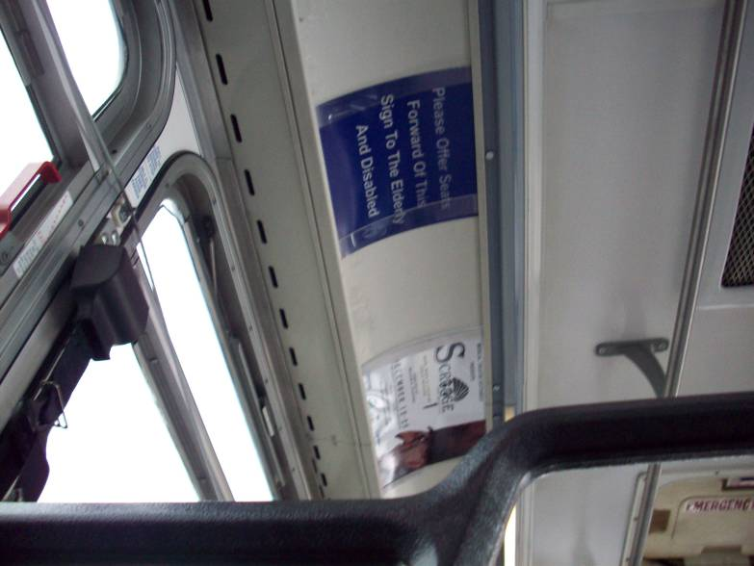
These signs really only work as long as the bus is brightly lit and the passenger looks up (not the normal line of sight of a person walking down the aisle). Pictured below is another photo of the right side of the same bus with no priority seating sign in the advertising rack (there was none on the window or bulkhead either).
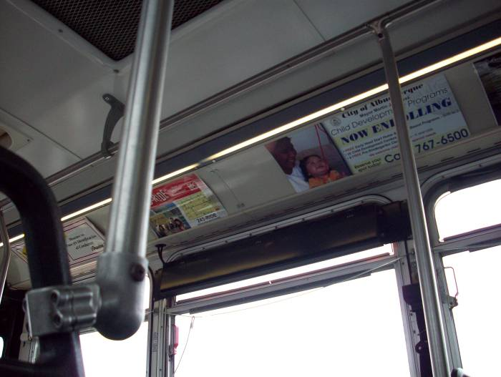

In the time since the conduct of this study and the delivery of the report, ABQ ride has reported that they have procured new window decals, modeled on the decals installed on their newest low-floor coaches, and have installed them in every bus in their fleet. These decals are installed on the windows just above the priority seats. This remedy should fully satisfy the ADA requirements and should also be very helpful to customers. We recommend that ABQ Ride consider integrate inspection of these decals into the bus preventative maintenance cycle.

3. Overall Conclusion
This analysis is the fourth in a series that started in 2005. Over these years, ABQ Ride’s determination and commitment to improve stop announcements and services to passengers with disabilities is clearly evident. ABQ Ride has exhibited a simple yet critical understanding that sustained moderate effort over a period of years is the key to changing the organization. Not only have they retired all of their older non-accessible buses, they have also worked hard to improve the reliability and consistency of their stop announcements across their mixed fleet. This last is particularly commendable as it requires management to work with different systems of different vintages to get them all working in a way that the customer receives the same experience, no matter what bus they are riding in. While we experienced the inside wayfinding announcements to have been pretty fair from the start, these announcements seem now to be almost universally compliant. The real improvement in stop announcements has been seen in the bus identification announcements. When we conducted our first analysis, these announcements were spotty and frequently difficult to hear. This is no longer the case. External bus identification announcements are now as reliable and as common as the internal wayfinding announcements. We believe that ABQ Ride’s current stop announcement program is on par with the best in the country. Their success rare seems to remain in the high 90% range, which is within the reasonable realm of normal equipment reliability. The only area remaining to be addressed in stop announcements is driver involvement in making announcements when the system occasionally fails. Even in this area, we initially observed virtually no driver participation in our first assessment but this has improved to the point that drivers are making announcements about half of the time when they are necessary. This is a significant improvement and ABQ Ride’s commitment to continue pressing forward in this area is very credible, based on their record of success.
With regard to services for passengers with disabilities, we continue to be impressed with the accessibility of Albuquerque’s streetscape and bus stop system. This wonderfully accessible built environment, combined with the level topography of the city, makes Albuquerque one of the most wheelchair friendly cities we have ever seen. ABQ Ride’s drivers, likewise, are among the most friendly we have encountered. The piece that seems to have been missing was a culture of proactive assistance to passengers with disabilities. In this area as well, we have seen improvement, though these remains further room to grow. Based on their success addressing stop announcement problems, it is reasonable that management’s commitment to revising the driver training and enhancing supervision of driver performance will yield results in these areas as well.

