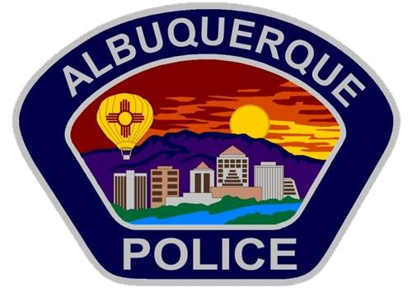

For Immediate Release: Thursday, June 28, 2018
Contact: Gilbert Gallegos, 377-6952

APD News Briefing on Officer-Involved Shooting
Offender held up store at gun point, fired shots during chase

ALBUQUERQUE – Today, the Albuquerque Police Department (APD) released details of the June 16 officer-involved shooting in which an offender was fatally wounded. APD reviewed details and video from the incident with the media at a news briefing.

On June 16, 2018, APD officers in the Northeast Area Command were dispatched at 3:24 p.m. to a reported armed-robbery at the Verizon store located at 2525 San Pedro NE. The offender took phones and cash from the business, and threatened employees and customers with a handgun as he robbed them of their phones and personal items, such as jewelry. The offenders were tracked and pursued as they drove through Southeast residential neighborhoods, firing at police officers and finally fleeing to Smith’s Grocery Store on Yale Blvd. The pursuit ended with a foot chase in the parking lot, which resulted in an officer shooting the offender before he could create a violent hostage situation in the store.

The suspects were later identified by APD with assistance from the FBI as being Richard Rivera and Jennifer Rael. Rivera was wanted at the time on a felony warrant for armed robbery, and he was considered armed and dangerous.

After the armed-robbery at the Verizon store, additional officers spotted a white van at a restaurant at Louisiana and Central, and were able to conclude that the van contained the stolen phone that was being tracked. Officers witnessed the male suspect, Rivera, drive the van from the restaurant. They followed him as he drove slowly through several neighborhoods. Officers attempted to stop the van with spike belt near Copper and San Pablo N.E. The van was able to continue on, despite the deflation of the front left tire.

Officers started a vehicle pursuit at that point along westbound Central Avenue. During the pursuit, an officer reported seeing the driver fire his handgun toward officers from the window of the van.

Rivera eventually turned from Central into a Southeast neighborhood, where police attempted the first of three Pursuit Intervention Technique (PIT) maneuvers to attempt to stop the vehicle. After one of the police vehicles struck the van, an officer reported seeing the driver point a handgun out of the window. The officer fired several rounds hitting the van. Rivera was able to flee in the van, heading south toward Columbia and Garfield, where another PIT maneuver failed to stop the van.

Rivera fled west on Garfield and eventually ended up on eastbound Coal Avenue, where a third PIT maneuver successfully stopped the van in front of the Smith’s grocery store at 320 Yale Blvd., S.E. Rivera fled on foot from the van and sprinted through the Smith’s parking lot as an officer holstered his gun and chased him. As Rivera veered toward the entrance of the Smith’s, the officer yelled at Rivera to stop. The officer later stated that he saw Rivera looking over his shoulder during the chase and reaching to his right hip area, as if to possibly draw a firearm. The officer, as well as an eyewitness, later recalled hearing Rivera say several times, “I have a gun.”

The officer also stated that during the foot chase, he noticed shoppers at the entrance of the Smith’s, which is where Rivera was headed. The officer said he feared that if Rivera was able to reach the entrance, he would take civilian hostages and use them as a human shield to continue to shoot at police. The officer made the decision to fire his weapon at Rivera to prevent him from reaching the entrance. He fired six rounds, striking Rivera four times. APD and AFR personnel at the scene performed emergency medical assistance until Rivera was taken to the hospital, where he died from his wounds.

###

