Mental Health Response Advisory Committee (MHRAC)
Meeting Minutes
April 16, 2024
Via Zoom
Board Members in Attendance
Commander. G. Bartlett Crisis Intervention Division
Dr. Nicole Duranceaux APD Behavioral Science Services
Betty Whiton NAMI
Mariela Ruiz-Angel /Walter Adams Albuquerque Community Safety
Chief Emily Jaramillo Albuquerque Fire Rescue
Mary Perez UNM Psychiatry & Behavioral Sciences
Robert Salazar Peer Representation
Coty Maxwell Crisis Intervention Division
Dr. David Ley New Mexico Solutions
Paula Burton Peer Representative
Ryan Delaware Albuquerque Health Care for the Homeless
Bernice Varela Crossroads for Women
Gilbert Ramirez Health, Housing, and Homelessness
Jane Garland NAMI Albuqueque

Introduction to MHRAC
The Mental Health Response Advisory Committee (MHRAC) was created by the Court Approved Settlement Agreement (CASA). We’ve been around since day one and have a focus on three areas, resources, and resources being available to access different things within the city that APD and first responders can use as it impacts homelessness and mental health issues. We are also involved in training and policy; training is one of those things we made a tremendous impact on. As far as the training that is offered. Policies are one of those things where the MHRAC is involved with assisting in writing approving, and recommending policy as it relates again to the narrow focus; we think narrow, but sometimes it gets pretty wide-focused on how law enforcement interacts with those experiencing homelessness and those experiencing a mental health crisis.

Fathom Summary
Introductions and Agenda Approval
Introductions were made for new attendees, including a CIU sergeant and data scientist. The agenda was then approved without changes.
APD Behavioral Health Data Report
APD's data scientist presented a detailed report on behavioral health incidents responded to by APD in 2023, including demographics, outcomes, transports, use of force cases, and trends over time. Discussion focused on improving data collection and identifying at-risk individuals.
ACS Updates on Response and Transport
ACS reported ramping up response, including transporting over 900 individuals to shelters in early 2022. A receiving area is planned at Gateway to divert non-emergency cases from hospitals. Federal reimbursement policies were discussed.
Gateway Health Hub Construction and Services
Gateway construction is ongoing with medical sobering, respite housing, and navigation beds planned. A pilot receiving area operated with UNM. Pursuing Medicaid reimbursement for sobering centers was highlighted as a sustainability strategy.
APD, CIU, and BSS, Updates
New CIU leadership was introduced. Referrals, cross-commissioning with other agencies, and community outreach were discussed. Prisoner Transport Unit (PTU) and Transit Safety Unit policies will be reviewed by the MHRAC going forward.
Crisis Receiving Center Opening
A new crisis center is expected to open this summer with double existing bed capacity. Its role in relieving other systems was discussed, alongside the prevalence of behavioral health clients throughout the legal and medical systems.

Attendance of Board Members, Brenda Vigil-Gallegos
Fourteen of Sixteen MHRAC Board Members were in attendance.

Welcome First-Time Guests
Joann Lopez, Sergeant, Albuquerque Police Department (APD)
A field Sergeant with APD who is currently working with the Crisis Intervention Division

Amalie McKee, PhD Data Scientist, Albuquerque Police Department (APD)
Will be presenting the 2023 CIU Annual Report to the MHRAC

Approval of Meeting Minutes
1st Motion – David Ley asked if anyone opposed the minutes from the March meeting.
2nd Motion – No second motion was made
Minutes from the March 2024 meeting were approved.

Public Comment (Two minutes per person), David Ley
There was no public comment made

Nomination of New Board Members, (if any)
No nominations were made

2023 CIU Annual Report, Dr. Amalie McKee
A complete version of the 2023 CIU Annual Report, can be found under Documents Related to APD's Settlement Agreement — City of Albuquerque (cabq.gov)
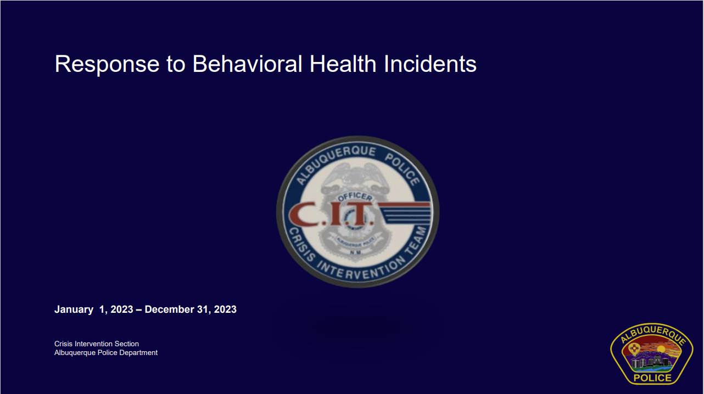
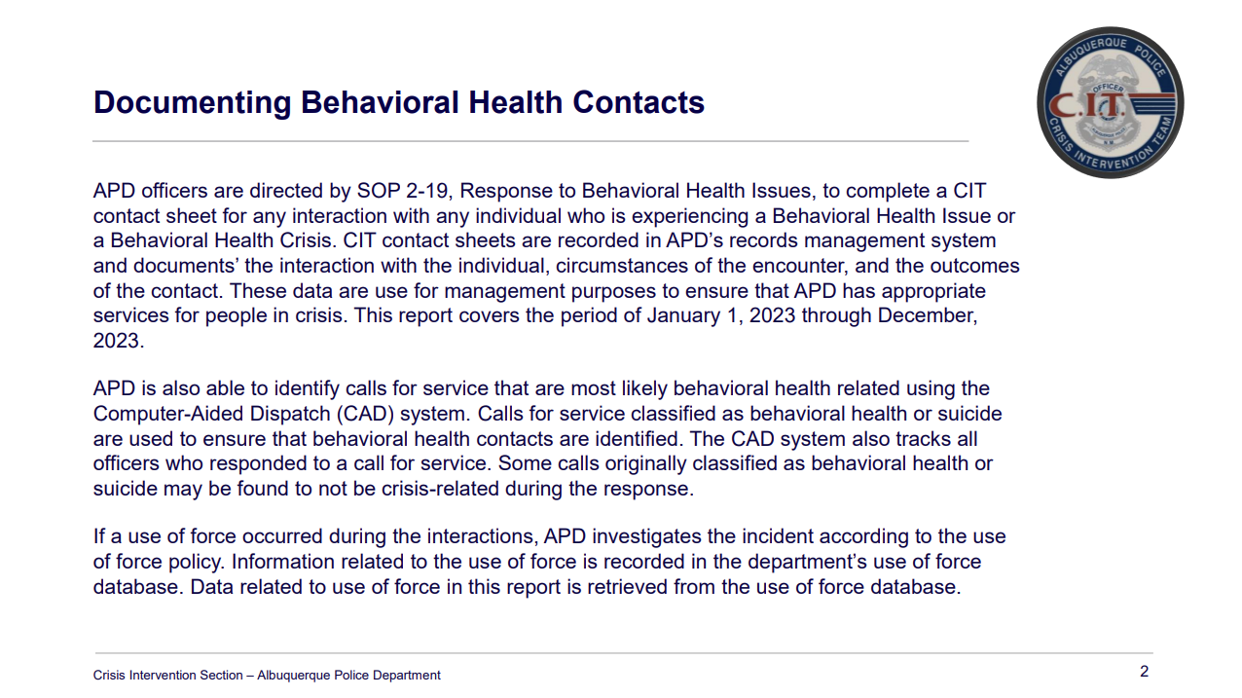

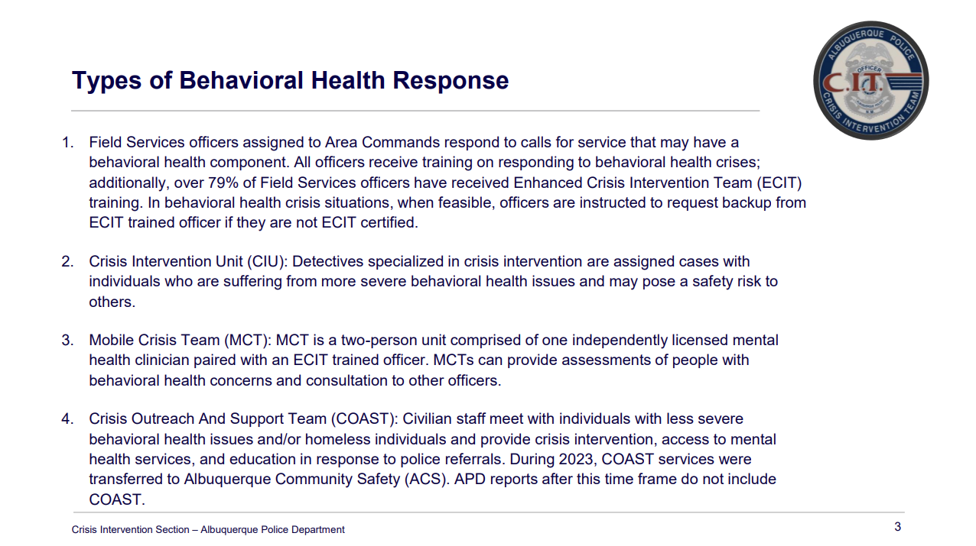

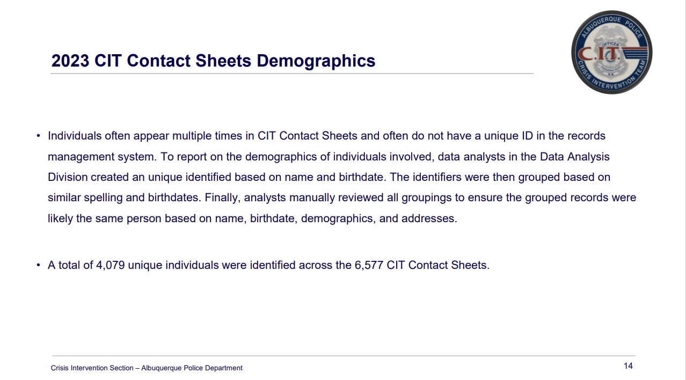

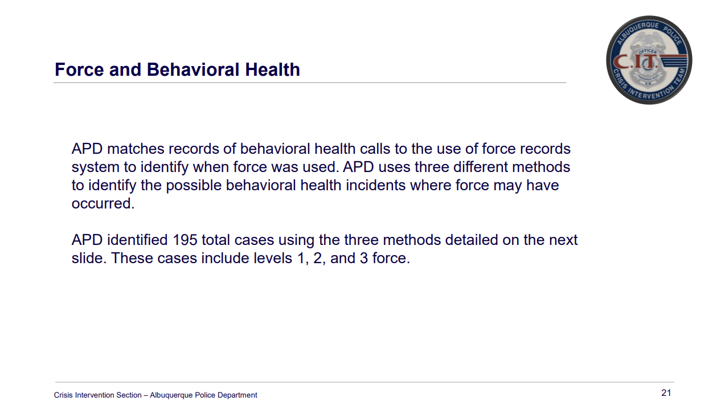

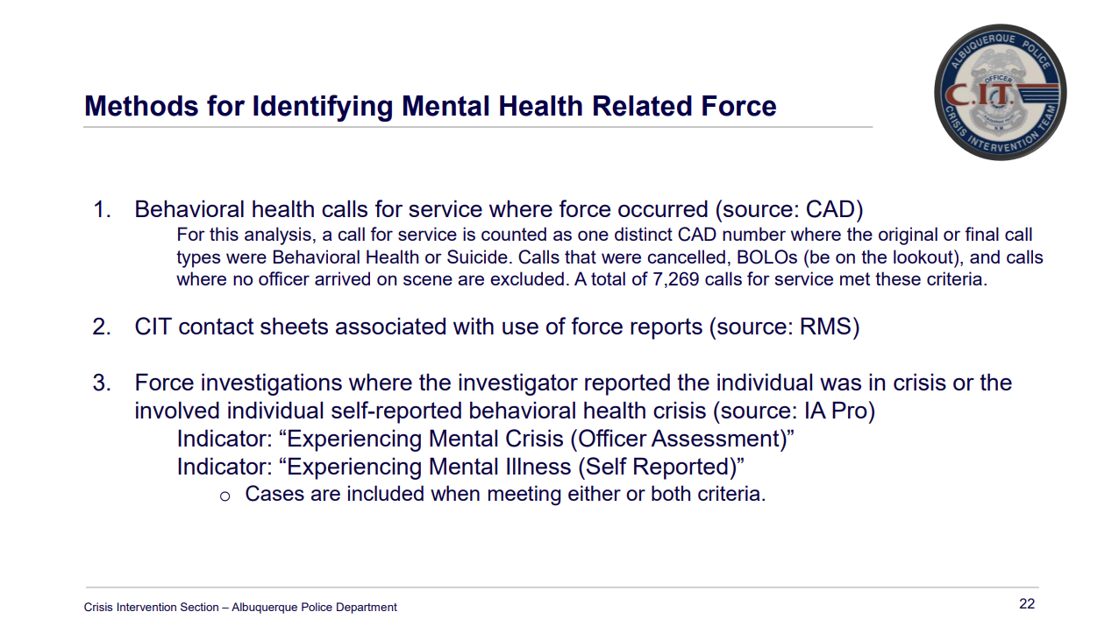

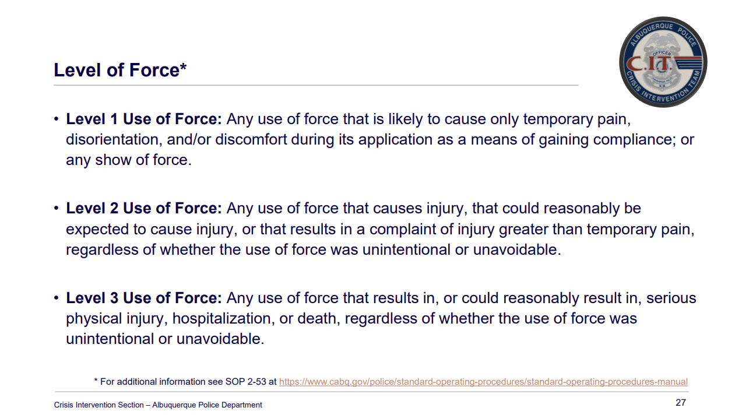

Albuquerque Community Safety Department (ACS) Update, Walter Adams
- Our last ACS Academy is now out in the field on their second week of OJT
- Over the next couple of weeks they will go through supervisor evaluations, evaluations, and hopefully in the next three to four weeks they will be fully out into the field.
- We have an upcoming shift for our responders coming up in June.
- The biggest update is the ACS emergency transport service that is being conducted during graveyard. We have transported 00 people to shelters between January and the beginning of April. That was intended to be up and running during the coldest months of the year so the phone number for that service is no longer active.

Gibson Health Hub, Health, Housing, and Homelessness, Gilbert Ramirez
- We had a visit from Cabinet Secretary Doucette and Representative Ben Ray Lujan regarding federal monies that were applied for but did not receive.
- We received $4.2 million in earmarks from our delegates; it was between Stansbury, Heinrich, and Ben Ray Lujan.
- About $2 million of that was a SAMHSA Grant for operational dollars and the other $2.2 million was for construction of the project.
- Without funding we issued a RFP that is currently out and open for an operator for the Medical Sobering Center. The timeline for that is still set for the winter of 2024 with the hopes of a sooner timeline. The RFP closes on the 19th.
- The Medical Respite is an additional project we have at Gateway which will provide 50 beds for folks to heal post discharge from UNM. The UNM hospital has individuals experiencing homelessness and oftentimes don’t have a safe place to heal and through our partners oftentimes use motel vouchers.
- We are going to have a focus dedicated 50 beds to allow individuals to stay up to 45 days longer if needed.
- To get their healthcare, we are doing this in partnership with healthcare for the homeless as well as First Nations Community Health Clinic.

CIU, APD, and BSS Report and Update, Commander Bartlett, Dr. Duranceaux, Lt. Lowry, and Sgt. Tinney
- Commander Dietzel is officially retired from the CIU effective April 6th, 2024.
- I bring with me the Prisoner Transport Unit (PTU) and the Transit Safety Unit (TSU)which I also oversee.
- The PTU and TSU policies are not typically policies that the MHRAC reviews, but I would like to present them to the MHRAC.
- There is a lot of overlap between the population that Transit Safety, ACS, and CIU work with and would pass through the PTU so MHRAC reviewing the policies would be helpful.
- Transit Safety is a new thing for APD so we have collaborated with ACS and Metro Security on behavioral health-related areas.
- Dr. Duranceaus has known Commander Gerard for several years and they are working on making sure they are tight on the BSS side with response. There is also the collaboration with BSS and CIU which they are working to keep it that way and work out any potential conflicts, especially with behavioral health response.
- Last the month of March the Home Visit side of the CIU had 472 new referrals, 108 were assigned, and 35 were referred to outside agencies.
- The Rio Rancho Police Department (RRPD) is pushing to start a CIT program there. Some RRPD officers are attending the MHRAC.
- We are going to get cross-commissioned with Sandoval County and with Rio Rancho so if they need help on the higher cases. we will be able to go there and everything will be good to go.
- The CIU Home visit team went to Dennis Chavez Elementary School to talk about police work and the uniqueness of the unit. They were able to take the CIU crisis dog, Oakley, to meet the kids. The team talked about the importance of being happy and staying happy and helping for transparency purposes.
- CIU has a quarterly newsletter that they recently started again. It will be going out through an internal platform, PowerDMS. By using PowerDMS, officers sign off on viewing the items that have been put through. The department also uses PowerDMS to send policies, training, special orders, etc. It is intended to keep APD officers updated.
- See the snip of the news letter below.
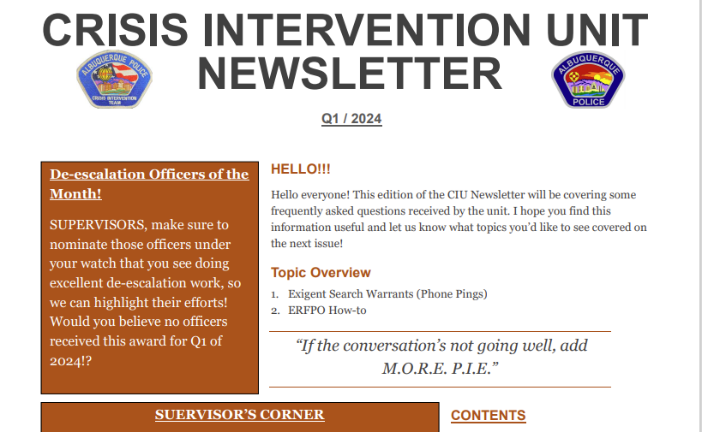

MHRAC Training and Infoshare Sub-Committee Update, David Ley
- Our next subcommittee is scheduled for Monday, April 29, 2024

MHRAC Final Discussion, Mary Perez
- There is anticipation to open the Crisis Center sometime this summer.
- We will have double the capacity.
- We have partnered with the county which will be a good resource.
- We are working with MDC now. In March of 2023 when the project started being worked on we found that about 90% of the incarcerated folks at MDC were lready our patients and I am assuming that is through the whole continuum.

Next meeting: May 21, 2023

