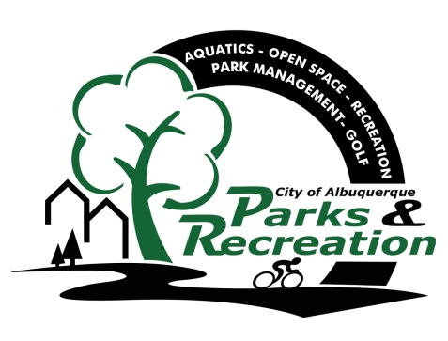

Notice of Public Hearing for Rule Making
On the
Parks and Recreation Department Policy with Regard to Private Tennis Lessons
The public hearing will be conducted at:
Jerry Cline Tennis Center
7001 Constitution Ave NE, Albuquerque, NM 87110
August 22, 2017 from 5:30pm to 7:30pm
Hearing Officer is:
Gregory P. Smith, Deputy Director, Department of Municipal Development
The purpose of the public hearing is to receive public comments on the proposed Parks and Recreation Department Policy with Regard to Private Tennis Lessons. The proposed policy sets up guidelines for the use of public tennis facilities for private lessons and stipulates standards instructors must meet. To see the full text of the proposed rule please follow the link below to view the proposed rule on the City of Albuquerque’s website.
http//www.cabq.gov/.xxxxxxxxxxxxxx (insert hyperlink once pdf of policy is posted on City website)

In accordance with §2-15-1 of the City of Albuquerque, New Mexico Code of Ordinances.

