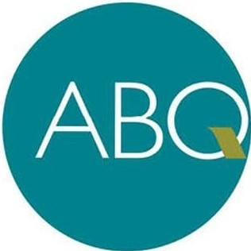
RIDE

FREE FARES
on all ABQ RIDE
buses and Sun Vans for students age 25 and younger, seniors age 60 and over
Students 25 years of age or younger can board the bus or Sun Van for free with an ID from a college or post-secondary institution or a class schedule. Seniors 60 years of age and older (also referred to on ABQ RIDE's website as "Honored Citizens") will be asked to show their ID or their
Transit Department-issued Honored Citizen ID to ride for free.
Information at 505.243.7433 or abqride.com
*4 for free student passenger
*5 for free senior passenger

