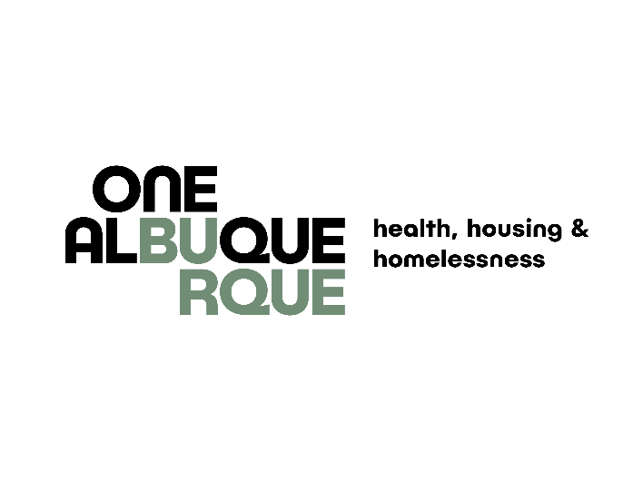

**REQUEST FOR QUALIFICATIONS**

**October 2024**

**The City of Albuquerque Department of Health, Housing & Homelessness (DHHH) is seeking qualified, not-for-profit organizations to administer Permanent Supportive Housing voucher programs using a housing first approach.**

Permanent Supportive Housing (PSH) is rental assistance and supportive services that help households experiencing homelessness or at high risk of homelessness obtain and maintain housing. PSH is not time limited. At least one member of the households must have a disability, which includes a verified physical or behavioral health disability.

PSH can be scattered site, meaning that households select their own apartment from the private rental market. For this RFQ, PSH may also be project-based, meaning the voucher would be attached to specific rental units.

**Available Funding**

For Fiscal Year 2026, the Department will seek to allocate up $12million in Permanent Supportive Housing programs. These programs will commence at the start of the Fiscal Year, July 1, 2025. If necessary, awardees may need to accept participants from PSH programs that are concluding. The Department will assist with this coordination.

**Funding for this RFQ is subject to City Council approval and availability of City General Funds.**

DHHH will use a Request for Qualifications (RFQ) process to contract with not-for-profit agencies to administer a PSH program. DHHH Procurement Rules for Social Services Contracts allows DHHH to procure social services through prequalification of potential Offerors in order to move expediently when opportunities arrive.

**Required Qualifications**

Qualified not-for-profit organizations must:

1) Have experience successfully administering supportive housing programs (RRH and/or PSH) and/or providing supportive services to households experiencing homelessness and at high risk of homelessness; and

2) Have the organizational capacity to administer a supportive housing program and comply with the City’s Administrative Requirements[1], including adequate financial and administrative oversight systems and staffing; and

3) Must be able to operate a PSH program with reasonable project costs, including staffing and administrative costs.

4) A completed financial audit with no major deficiencies identified in the report. The financial audit must be recent – within the last two years.

**Timeline**

**Applications for qualifications will be accepted on a rolling basis. Interested organizations are encouraged to submit their applications promptly, so that DHHH may begin allocating the funds.**

**To guarantee funding and a July 1, 2025 start date, applicants are encouraged to apply before December 31, 2024.**

**Review Process**

An Ad Hoc Committee, comprised of DHHH staff, will review and qualify applicants as applications are received. The Committee will rank-order qualified applications, based on extent to which they meet the criteria listed in this RFQ. The results of this process will be a pool of qualified applicants that are rank ordered. From this pool, DHHH will negotiate and enter into contracts with qualified organizations to administer PSH programs. DHHH will use rank-order information when selecting agencies to contract for these services.

**Submission Process**

Interested not-for-profit organizations must:

**1) Submit a narrative that addresses the following questions.** The narrative should be limited to eight (8) pages and use 12-point font on 1-inch margins. Please address each question in the order listed below with a clear heading title.

**A. Experience with Supportive Housing:** Describe the organization’s experience administering supportive housing programs. Indicate whether the organization’s experience is administering RRH, PSH or both. Provide quantitative housing outcome data for the last three years. Outcome data should include the number of households who remained in the program or exited to another type of permanent housing. If the organization has not administered supportive housing programs, describe any similar programs that you have operated (i.e., transitional housing).

**B. Experience with Supportive Services for Households Experiencing Homelessness or At Risk of Homelessness:** Describe the organization’s experience providing supportive services to people experiencing homelessness and/or at risk of homelessness. Include information regarding any evidence-based best practices that are routinely used by the organization (e.g., motivational interviewing, individualized service plans).

**C. Organizational Capacity:** Describe your organization’s organizational capacity to administer supportive housing vouchers. Describe the staff and administrative structure that would be used to administer the supportive housing vouchers, including both rental assistance and case management /supportive services components. Describe the financial systems and staffing your organization has in place to administer supportive housing vouchers. Describe your agency’s experience, if any, in adhering to the City’s Administrative Requirements. Describe the agency’s capacity to utilize Medicaid and third-party insurances for applicable supportive services.

**D. Subpopulations:** Describe any expertise and experience your organization has in serving specific subpopulations (i.e., domestic violence survivors, youth ages 16-24, families with young children).

**E.** **Program Capacity:** Indicate how many households the organization is able to serve with the proposed funding amount. Include justification how the number was calculated such as FMR, staffing, etc.,.

**2. Complete the following annual budget estimate for costs to operate the PSH program.** If DHHH contracts with the organization to provide PSH programs, the organization will develop a more detailed project proposal and budget at that time. The purpose of these charts is to provide a basic overview of estimated project costs. The form can be found under the “[Permanent Supportive Housing RFQ](https://www.cabq.gov/health-housing-homelessness/partner-resources)” section of the URL below. An example of the form can be found at the end of this document.

**3) Most recently completed financial audit**

**4) Documentation of not-for-profit status**

Complete applications with narrative, estimated annual budget, financial audit and documentation of not-for-profit status should be submitted via email to [HPI@cabq.gov](mailto:HPI@cabq.gov).

Questions regarding the RFQ may be sent in writing to [HPI@cabq.gov](mailto:HPI@cabq.gov). Questions and answers to all inquiries will be posted at <https://www.cabq.gov/health-housing-homelessness/partner-resources>

**Applications for qualifications will be accepted on a rolling basis until funds are allocated. Applicants are encouraged to apply before December 31, 2024.**

All notices, forms and supporting documents of the RFQ will be posted [BELOW](https://www.cabq.gov/health-housing-homelessness/partner-resources):

<https://www.cabq.gov/health-housing-homelessness/partner-resources>

**BUDGET SUMMARY**

|  |  |
| --- | --- |
| **Number of households being housed:** | |
| **Population Served (youth, adults, families, etc.,):** | |
|  |  |
| **Expenditure Category** | **Program Total** |
| **Personnel Costs** |  |
| Salaries & Wages |  |
| Payroll Taxes and Employee Benefits |  |
| **Total Personnel Costs** | $ - |
|  |  |
| **Operating Costs - Direct** |  |
| Contractual Services |  |
| Audit Costs |  |
| Consumable Supplies |  |
| Telephone |  |
| Postage and Shipping |  |
| Occupancy (rent, utilities, other) |  |
| Equipment Lease/Purchase |  |
| Equipment Maintenance |  |
| Printing & Publications |  |
| Travel (local, out of town) |  |
| Conferences, Meetings, Etc. |  |
| Direct Assistance to Beneficiaries |  |
| Membership Dues |  |
| Equipment, Land, Buildings |  |
| Insurance |  |
| Fuel and Vehicle Maintenance |  |
| **Total Operating Costs** |  |
|  |  |
| **Total Direct Costs (Personnel & Operating)** | $ - |
|  |  |
| **Indirect Costs** |  |
|  |  |
| **TOTAL PROGRAM EXPENSES** | $ - |

1. <https://www.cabq.gov/health-housing-homelessness/partner-resources/administrative-requirements>