HOW-TO GUIDE
LIQUOR LICENSE NOTIFICATION REQUESTS

The Office of Neighborhood Coordination (ONC) has implemented a new online form for applicants to submit a request to ONC in order to obtain neighborhood or homeowner association contact information. The new online form saves you the time of having to visit our office in person. The following steps will assist you in completing this new form:

- Open your web browser and go to: http://www.cabq.gov/office-of-neighborhood-coordination/liquor-license-submittal-form

- All of the fields associated with this form that must be filled in order to submit it to ONC are marked with a red check mark

- You will need to enter the: Contact Name, Company Name, Business Name, “Doing Business As” Name, Site Address, City, State, Zip Code, Telephone Number, Email Address, Liquor License Hearing Date, and the Zone Atlas Page.

- If you do not know the Zone Atlas Page for your site, follow these steps to determine which page your site is located on (If you already know the Zone Atlas Page on which your site is located skip to Step 5):

  - Access the City of Albuquerque’s Zone Grid Map via the link located at the bottom of the ONC’s online web form:
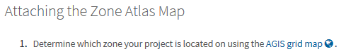

  - This will open a new browser tab. Enter the site address in the search field at the top right hand corner of the screen:

  - The website will then zoom to the site address, and the corresponding Zone Atlas Page will be shown highlighted in red font:

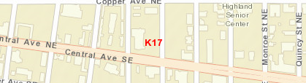

- Once you have determined the appropriate Zone Atlas Page, click on the “Download the corresponding Zone Atlas Map” link at the bottom of the web page.

- This will take you to an alphabetized Zone Atlas Index.

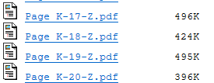
- Scroll to the appropriate Zone Atlas page.

- Click on the link to access a pdf copy of the Zone Atlas Map.

- Save the pdf version of the map to your desktop and highlight the subject site (Note: You may print the map, mark it and scan it, or you can utilize a pdf editor software program to highlight the pdf).
  - To Highlight within the PDF:
    - Go to TOOLS and open the “comment” tools.
    - Using the shapes tool, you can either draw a rectangle around the site or trace the site using the connected lines.
    - You can change the color and thickness of your line as needed.

- Go back to the ONC online web form and attach your saved map to the online form.

- Once you have filled out all of the require fields and attached the Zone Atlas Map, simply click the “Submit Form” button at the bottom of the online web form to transmit your request to ONC. We will then process your request in the order that it was received.

As always, should you have any questions or need any additional assistance, please don’t hesitate to contact our office.

