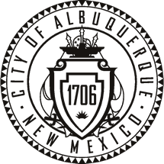

CITY OF ALBUQUERQUE,
OLD TOWN PORTAL MARKET ADVISORY BOARD
Agenda

Wednesday, November 9, 2016 at 5:00 P.M.
Police sub-station, SE corner of Rio Grande Blvd. and Central Blvd.

- Establish Quorum

- Approve Agenda

- Approve Minutes

- An effort to clarify the most recent guidelines for Special Shape Centerpieces the Board will examine examples of various beads and centerpieces

- Portal Managers Report

- Old Business

- New Business

- Adjourned

