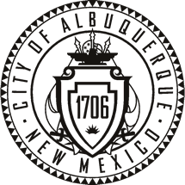

CITY OF ALBUQUERQUE,
OLD TOWN PORTAL MARKET ADVISORY BOARD
Agenda

Wednesday, January 11, 2017 at 5:00 P.M.
Police sub-station, SE corner of Rio Grande Blvd. and Central Blvd.

- Establish Quorum

- Approve Agenda

- Approve Minutes

- Sharing credit card processing equipment between craft units

- New Business

- Old Business

- Portal Managers Report

- Adjourned

