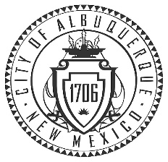
City of Albuquerque
Cultural Services Department

ABQ BioPark Advisory Group
MEETING AGENDA

Tuesday, November 3, 2020 4:00- 5:00 pm
Via Zoom Video Conference
For link to Zoom meeting please contact kortiz@cabq.gov

- Call to Order

- Approval of Agenda

- Approval of the Minutes

- Public Comments

- Introductions and Reports

- Announcements/Ongoing Project Updates

- New Business

- Next Regular Meeting – January 5, 2021 - 4:00 – 5:00 pm

- Adjourn

