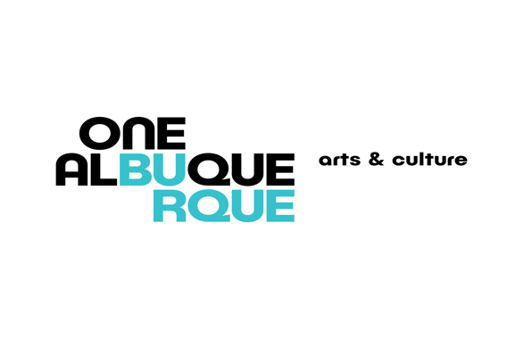

Albuquerque Museum Board of Trustees
MEETING AGENDA

Wednesday, February 8, 2023, 11:30 a.m. – 1:00 p.m.

Albuquerque Museum Auditorium

- Call to Order, and Authorization to Record
- Public Comment
- Approval of Board Meeting Minutes
  - December 14, 2022
- Appointment of the Nominating Committee for 2022-2023 Officers
- Report on the American Alliance of Museums reaccreditation status, Andrew Connors
- Museum Director Report, Andrew Connors
- Curators Reports
- Albuquerque Museum Foundation Report, Andrew Rodgers
- Adjourn

Next Regular Meeting – April 12, 2023, 11:30 a.m. – 1:00 p.m.

