**High Wind Fugitive Dust Mitigation Plan**

**Albuquerque-Bernalillo County**

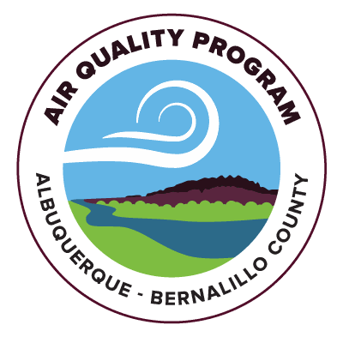

**April 2024**

**Table of Contents**

Purpose……………………………………………………………………………………………………………….3

Background……………………………………………………………………………………………………….…3

Health Impacts of PM10…………………………………………………………………….………………..4

Contributors to High PM10 Events…………………………………………………………………..….4

Air Monitoring Network………………………………………………………………………………………5

Role of Weather Forecasting……………………………………………………………………………….6

Public Education, Notification, and Outreach………………………………………..……….…..10

Measures to Minimize Contributing Controllable Sources………………………………….14

20.11.20 NMAC, Fugitive Dust Control……………………………………………………………….14

Reasonably Available Control Measures, 20.11.20 NMAC……………………………..……15

Agricultural Conservation Measures…………………………………………………………………..15

Integrated Vegetative Management…………………………………………………………………..16

Rangeland Management…………………………………………………………………………………….17

Alternative Control Measures…………………………………………………………………………….18

Fire Suppression and Invasive Species Management……………………………………..…..19

Unpaved Travel Surfaces…………………………………………………………………………………….19

Minimize Public Exposure to High Concentrations of PM……………………………………20

Processes to Collect and Maintain Data Pertinent to the Event………………………….20

Consultation with Other Air Quality Managers…………………………………………………..21

Periodic Review and Evaluation………………………………………………………………………….21

Public Comment Documentation………………………………………………………………………..22

Submission of Mitigation Plan…………………………………………………………………………….25

**Purpose**

On April 22, 2022, the Environmental Protection Agency (EPA) finalized a list of additional areas subject to the mitigation plan requirements of the 2016 Exceptional Events Rule codified at 40 CFR 51.930. Exceptional events may be caused by human activity that is unlikely to recur or by natural events.

The EPA determined that Bernalillo County, New Mexico has frequently recurring exceptional events for PM10 based on data from 2018-2020. In Bernalillo County, high wind events in a naturally arid climate can result in exceedances of particulate matter (PM) standards. Climate change also contribute to more instances of extreme weather events that can result in high PM10 levels, particulate matter the size of 10 microns. Therefore, the City of Albuquerque Environmental Health Department (EHD) has developed this High Wind Fugitive Dust Mitigation Plan for Albuquerque-Bernalillo County to address high PM levels due to wind events and to explore various control strategies.

**Background**

Bernalillo County consists of 1,167 square miles at an average elevation of over 5,000 feet. It lies in the far northern part of the Chihuahuan Desert, in a valley that extends 30 miles east-west[1]. The valley is bordered by the Sandia Mountains to the north, the Manzano Mountains to the east, and lava escarpments to the south and west[2]. The Rio Grande River runs through the City and continues south to the Texas border. West of the Rio Grande lies a number of dormant volcanoes. East of the valley lies Tijeras Canyon. The region overall is part of the tectonic Rio Grande Rift Valley. The County is surrounded by many tribal lands as well, including Isleta Pueblo to the south and Sandia Pueblo to the north.

The climate of the region is mild and dry, and rainfall can be sparse, with the City receiving less than 10 inches of rainfall annually[3]. The Sandia Mountains receive roughly 30 inches of rainfall in the summer, and roughly the same amount of snow in the winter[4]. Farmland and rangeland cover a portion of the County, particularly along the Rio Grande. Windstorms are common, especially in the spring months. In Bernalillo County, high winds usually occur near cold fronts. Also, thunderstorms can sometimes generate high winds for multiple hours.

**Health Impacts of PM10**

Dust and particulate matter can irritate sensitive lung tissue and cause health problems, especially with vulnerable groups such as infants, children, teens, the elderly, pregnant women, people with respiratory conditions, and people with heart disease[5]. Healthy adults working or exercising outdoors may also be affected by these high concentrations of dust.

When dust is contributing to poor air quality, the best precaution to take is to simply avoid going outside[6]. When one must go outside, it is recommended to avoid hard exercise. Wearing a covering over your nose and mouth can provide some protection from large particles.

Mitigating for the effects of dust and PM10 pursuant to measures discussed in this mitigation plan and 20.11.20 NMAC can help reduce the likelihood of experiencing health impacts as a result of high PM10 in the ambient air.

**Contributors to High PM10 Events**

Numerous factors contribute to high PM10 events in Bernalillo County. Lack of soil moisture, lack of vegetative cover, lack of precipitation, and high wind speeds, all of which can be exacerbated by the effects of climate change, add up to create weather conditions where a high amount of PM10can reach the ambient air. Of the many contributing conditions for dust initiation, strong winds are the most significant factor[7]. Minimal vegetation coverage and fallowed agricultural land also have an impact. Small plants distanced from each other provide ideal conditions for the initiation of blowing dust, as space reduces the amount of wind friction, allowing strong winds to reach the surface without interference and lift the dust particles[8]. Higher dust emissions occur in areas with bare ground, and more dust events were documented after the harvesting of crop fields when the surface cover was at a minimum[9].

In Bernalillo County, many of the high wind events take place in the spring. In areas to the south and southeast of downtown Albuquerque, a lack of vegetation, as well as anthropogenic activity, have contributed to high particulate matter readings at the South Valley monitor. The South Valley is a priority area for fugitive dust control efforts.

**Air Monitoring Network**

EHD’s Air Quality Program (AQP) regulates air quality to protect public health and the environment in Bernalillo County, excluding areas in New Mexico outside the County, which is regulated by the New Mexico Environment Department (NMED), and tribal lands.

Air monitoring data is required by regulation and is used to determine compliance with the national ambient air quality standards (NAAQS). EHD’s Air Quality Monitoring Program monitors regulated criteria air pollutants under the Clean Air Act (CAA) to facilitate the protection of public health and the environment in Bernalillo County. Federal mandate requires AQP air monitoring data for use in determining compliance with the NAAQS.

The AQP operates a network of six ambient air monitoring stations (Figure 1). All six stations are equipped with instrumentation to track windblown dust (*e.g.*, particulate matter with an aerodynamic diameter less than 10 microns and less than 2.5 microns, PM10and PM2.5). Additionally, all sites have instrumentation to measure meteorological parameters relevant to particulate matter transport (*e.g.*, wind speed, wind direction, temperature).

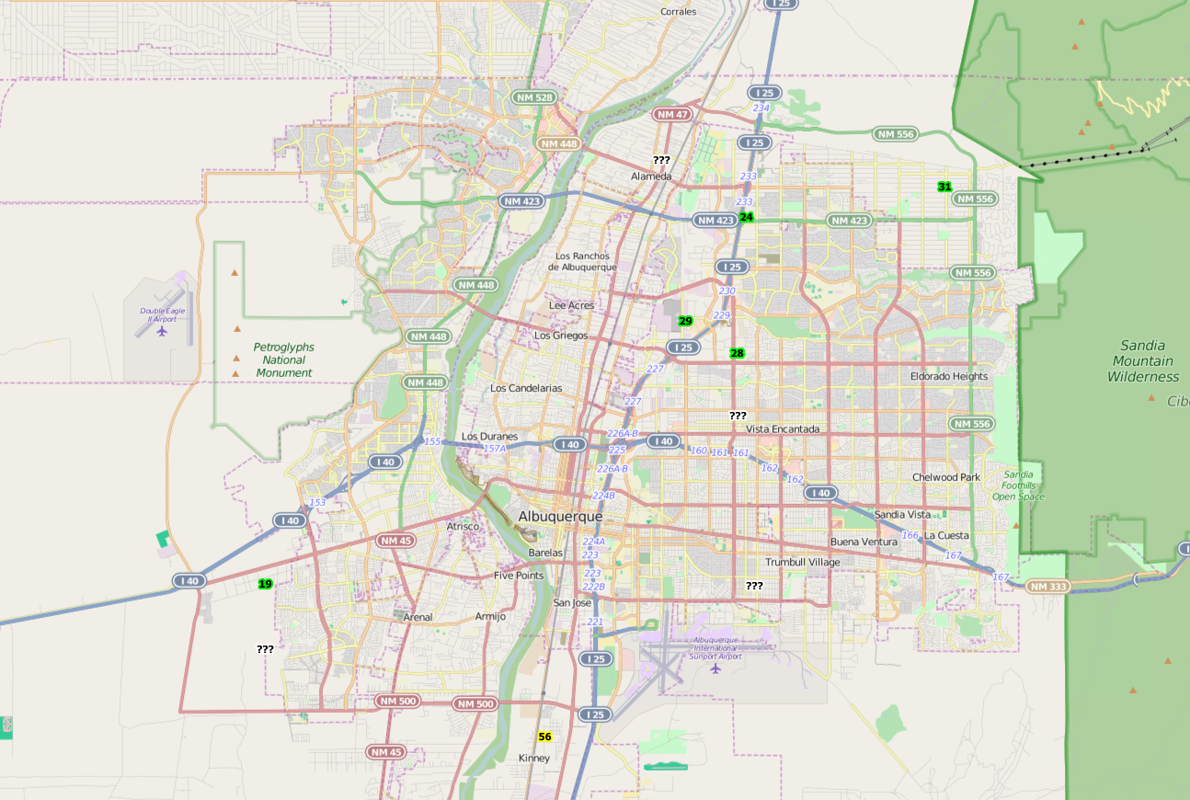

Jefferson (2ZS)

AQS ID: 35-001-0026

3700 Singer Boulevard NE

Lat: 35.1441, Long: -106.6044

South Valley (2ZV)

AQS ID: 35-001-0029

201 Prosperity Avenue SE

Lat: 35.0169, Long: -106.6572

Del Norte High School (2ZM)

AQS ID: 35-001-0023

4700A San Mateo Boulevard NE

Lat: 35.134263, Long: -106.585197

North Valley (2ZH)

AQS ID: 35-001-1013

9819A Second Street NW

Lat: 35.1930, Long: -106.6136

Foothills – Double Eagle Elementary School (2ZF)

AQS ID: 35-001-1012

8901 Lowell Street NE

Lat: 35.185, Long: -106.5077

San Jose Mobile Monitoring Station

AQS ID: 35-001-2022

2015 Galena Street SE

Lat: 35.0636, Long: -106.6476

**Figure 1: City of Albuquerque ambient air monitoring network**

**Role of Weather Forecasting**

Weather data and forecasts are monitored every weekday, and sometimes on the weekends, when conditions favor fugitive dust. For example, a lack of recent precipitation and strong winds are two of the more important factors that result in considerable fugitive dust. Figure 2 shows a dust storm from the Albuquerque International Airport (“Sunport”) looking northeast toward the mountains. Figure 3 shows the same view on a normal day.

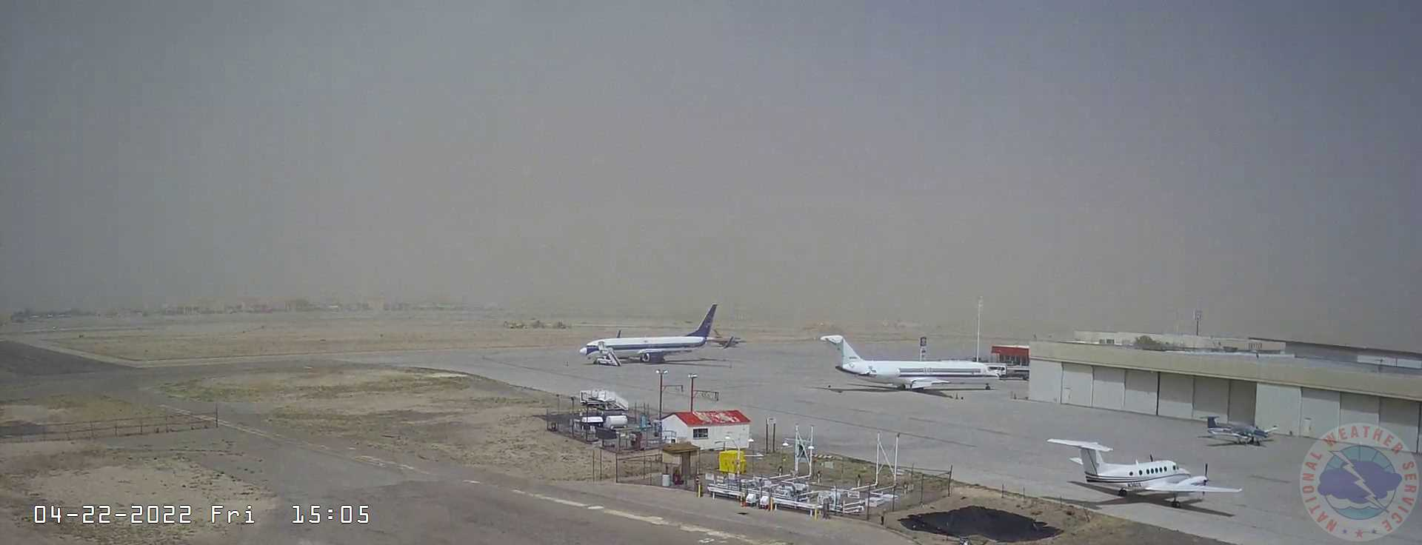

**Figure 2: 22Apr2022 dust storm from the Sunport looking northeast toward the mountains**

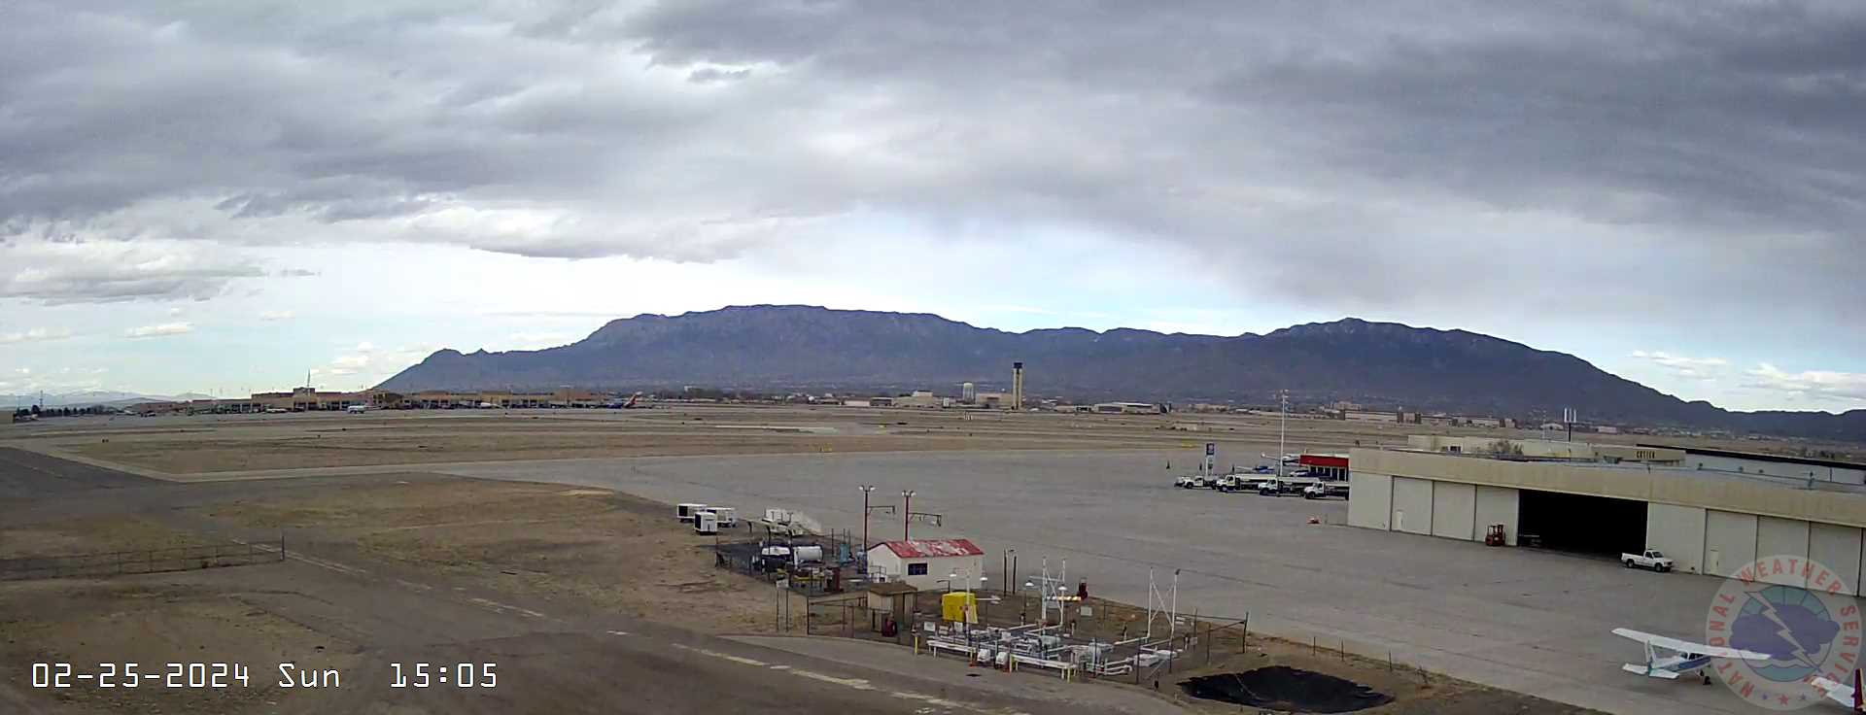

**Figure 3: Same view on a normal day**

When dusty conditions are expected, a discussion of those forecast conditions is written by the meteorologist on staff. The strength, direction, and timing of the wind along with other factors and a reminder to control dust are included in the discussion. Either the afternoon before or the morning of the event, the discussion is sent as an email to contractors and local businesses that generate dust.

Figure 4 shows an example of one of these emails with a subject line of “windy conditions Wednesday afternoon (02/21/2024)”.

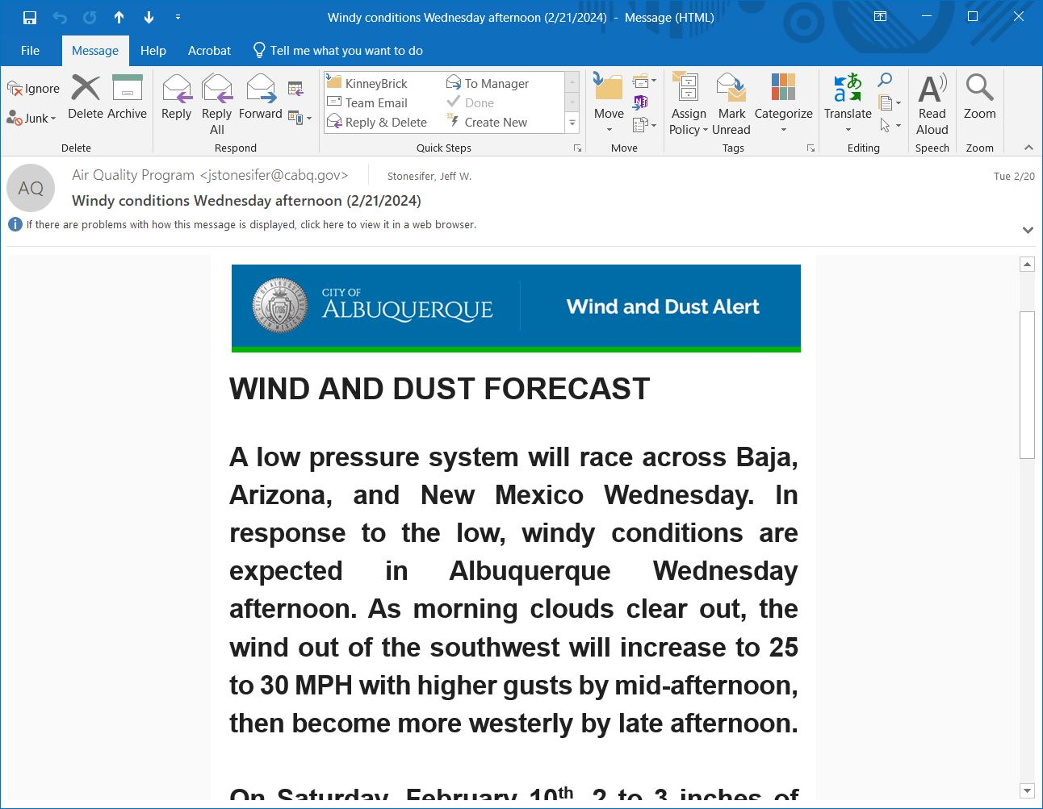

**Figure 4: wind and dust forecast sent to local contractors the afternoon of 2/20/2024**

20.11.20 NMAC, adopted by the Albuquerque-Bernalillo County Air Quality Control Board (AQCB), requires the AQP to issue stop work orders as needed. When sustained winds reach 30 miles per hour on a weekday and soils are dry, the AQP issues a stop work order to local contractors and businesses that generate dust. The meteorologist makes the decision to issue a stop work order based on observed wind speeds, recent rainfall, blowing dust visible on local cameras, and any other relevant information. Figure 5 shows an email with a stop work order for June 23, 2023.

EHD’s website explains shutdown notices in more detail[10]. The website also explains some steps the public can take during health alerts, such as limiting time spent outdoors, keeping windows and doors closed, and reducing exposure for vulnerable populations.



**Figure 5: Stop work order issued 6/23/2023**

The AQP issues health alerts for dust when the level of the 24-hour PM10 NAAQS could be exceeded due to blowing dust. The meteorologist makes this decision based on current and predicted wind speeds, recent precipitation and drought status, and current and recent PM10 levels. If the National Weather Service has issued a High Wind Warning or a Wind Advisory, this also plays a role in the decision to issue a health alert. The goal of the health alert isn’t to reduce fugitive dust, but rather to warn the public about high particulate levels. Figure 6 shows a health alert that was issued on May 12, 2023.



**Figure 6: Example health alert from May 12, 2023**

**Public Education, Notification, and Outreach**

As shown above, the AQP has a system in place informing the public about high dust days that exceed the NAAQS. Alerts warning of blowing dust are sent to subscribers on the Listserv, the press, and the RAVE emergency alert system via text, with a Spanish version for those who request it. In addition, alerts are posted on EHD’s social media platforms.

EHD hopes to increase public outreach and education efforts regarding best practices to reduce fugitive dust going forward, in addition to efforts already underway. EHD sends out press releases for many topics, and more releases focused on fugitive dust mitigation would help to better educate the public, as well as promote better management practices.

EHD currently hosts a fugitive dust training workshop at least twice a year to help educate the public and permittees about best management practices and assure compliance with 20.11.20 NMAC. Some of the topics include: regulatory oversight & regulations, the importance of controlling dust, construction permits, programmatic permits, asbestos & demolition, standard dust controls, alternatives & innovations, and final stabilization.

EHD has participated in City events where an information booth is provided and the public can ask questions about various programs, as well as sign up for alerts.

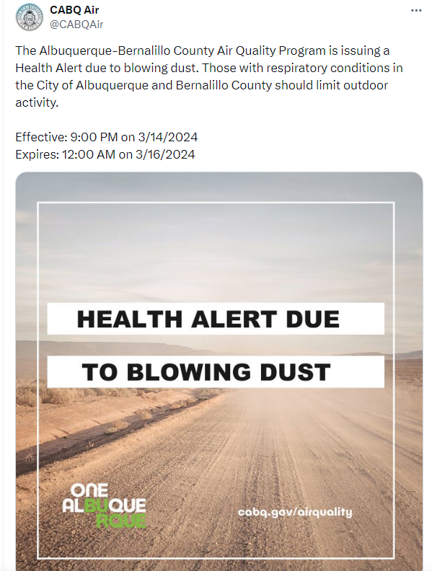

**Figure 7: Example Health Alert on Social Media**

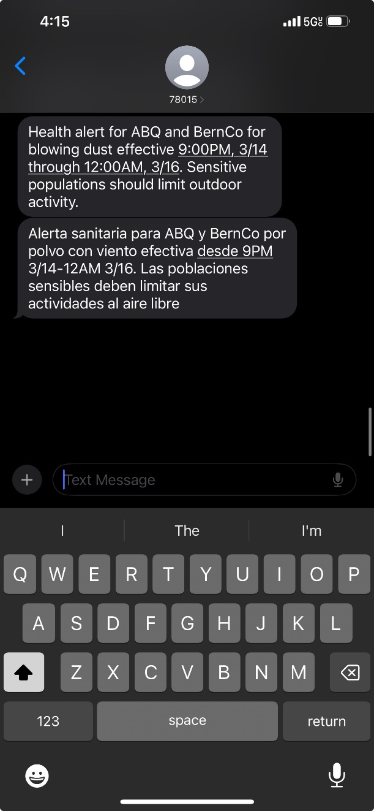

**Figure 8: Example Text Health Alert in English and Spanish**

Figures 7 and 8 provide some examples of the different form those alerts can take. The emergency alert system software, Rave Mobile Safety, helps to deliver real time health alerts to those who opt in to receive the information. Community members can text “ABQHEALTH” to the number 226787 on their phone, or “ABQSALUD” to opt into the Spanish language list[11]. Subscribers will immediately receive a welcome message as well as instructions to Start or Stop messages at any time. The service is free to those who enroll.

**Measures to Minimize Contributing Controllable Sources**

In developing mitigation plans, EHD must take steps to identify, study, and implement mitigating measures pursuant to 40 CFR 51.930(b)(2)(ii). Below are some of the current rules in place, as well as voluntary mitigation measures that would reduce the likelihood of high PM10 events throughout the County.

*Mandatory Measures*

20.11.20 NMAC, Fugitive Dust Control

The AQP regulates fugitive dust emissions primarily through 20.11.20 NMAC, Fugitive Dust Control. Any non-exempt project that results in a disturbance of three-quarters of an acre or more is required to obtain a fugitive dust permit and comply with the fugitive dust control permit. 20.11.20 NMAC was adopted by the AQCB in 2008. The rule has a program for both fugitive dust control programmatic and construction permits.

A programmatic permit is required under 20.11.20.13 NMAC for single or multiple facility locations to address real property totaling three-quarters of an acre or more that is subject to routine maintenance, routine surface disturbance activities, or routine ongoing active operations. Programmatic fugitive dust control permits are valid for five years.

A construction permit and fugitive dust control plan for those activities are required under 20.11.20.14 NMAC for any planned active operation that will disturb three-quarters of an acre or more. Construction permits for fugitive dust control are valid for one year from the date of issuance by the department or

until the project expiration date provided in the permit application, whichever is longer, but no more than five years from the date of issuance.

As part of the fugitive dust construction permit application, the application must include the total volume of bulk material being handled, total area of disturbance, project description, anticipated project completion date, site map, high wind contingency measures, and a description of any stockpiles, among other things.

Even if one is not required to apply for a fugitive dust control permit, 20.11.20 NMAC states that each person shall use reasonably available control measures or any other effective control measure during active operations or on inactive disturbed surface areas, as necessary to prevent the release of fugitive dust.

Reasonably Available Control Measures, 20.11.20 NMAC, *Fugitive Dust Control*

NMAC 20.11.20 has a number of reasonably available control measures permittees may use to control fugitive dust. Those measures include:

1. Use of wet suppression
2. Use of dust suppressants in the amounts, frequency, and rates recommended by the manufacturer to help stabilize sites
3. Reduction in vehicle speeds on unpaved roadways
4. Utilization of wind breaks (such as fabric fencing or other methods)
5. Performance of regularly scheduled vacuum street cleaning or wet sweeping
6. Application of gravel or other mulch material to surfaces with a size and density sufficient to prevent surface material from becoming airborne
7. Application of wet suppression and wind breaks for active stockpiles
8. Restriction of access to active stockpile areas during non-work hours
9. Maintenance of a stable outer crust to inactive stockpiles
10. Xeriscaping

At minimum, all projects requiring a fugitive dust control permit shall utilize paved or gravel entry/exit aprons, steel grates or other devices capable of removing mud and bulk material from vehicle traffic tires, and erect a properly-maintained fabric fencing material around the perimeter of the disturbed surface area with openings no wider than necessary to allow vehicles to enter or exit the area.

*Voluntary Measures*

Agricultural Conservation Measures

The Natural Resources Conservation Service (NRCS) of the United States Department of Agriculture has a Dust Mitigation Handbook to help mitigate PM emissions from agricultural cropland, rangeland, natural areas, and unpaved surfaces. When implemented well, NRCS approved measures will reduce the risk of non-attainment for PM10 in Bernalillo County. Implementation of conservation measures should be coordinated with agricultural producers, landowners, operators, state agencies, NRCS, and the EPA to determine the most suitable and effective conservation measures for the County. Control measures can include:

* Maintaining soil surface cover;
* Agricultural practices aimed at improving soil health;
* In-field pass reductions from vehicles;
* Soil conditioning and timing of operation modifications;
* Windbreaks & vegetative barriers;
* Equipment modifications;
* Unpaved roadway management;
* Reduction of reliance on commercial fertilizers;
* Land application of compost; and
* Improved pasture and range management

In addition, the New Mexico Department of Agriculture lists five principles of soil health. Those principles include (1) keeping soil covered; (2) minimizing soil disturbance on cropland and minimizing external inputs; (3) maximize biodiversity; (4) maintaining living roots where appropriate; and (5) integrating animals into land management, including grazing animals, birds, beneficial insects or keystone species, such as earthworms[12]. By maintaining healthy soil, moisture will be retained and the likelihood of dust formation due to wind erosion is decreased.

Integrated Vegetative Management

Erosion is a big part of high PM10 events and decreased visibility. Generally, the vulnerability of soil to wind erosion is determined by soil particle size distribution, organic matter content, moisture content, and soil structure, including the aggregate size distribution and presence of physical and biological crusts[13].

The New Mexico Department of Transportation (NMDOT) has invested over two million in Federal Highway Administration funds to improve road safety through management-based dust mitigation efforts in order to reduce the likelihood of dangerous dust events creating low visibility conditions on highways, notably off of Highway 10 near the Lordsburg Playa. NMDOT has also invested in integrated vegetative management efforts for roadsides to plant more native grasses and brush along right of way areas adjacent to roads. More of these efforts in Bernalillo County to reduce erosion and increase vegetation, whether from NMDOT or local entities, could help improve the likelihood of a reduction in high PM10 days throughout the County as well as help with visibility.

Additionally, the application of mulch or compost on soil can improve moisture retention for soil health, reducing the likelihood of erodible conditions from high wind events. In areas with more deciduous trees, leaving fallen leaves alone on the soil can be beneficial for the production of healthy microbes that feed the soil and improve soil conditions, creating a landscape that is less likely to produce dust. Most areas in Bernalillo County where dust is a concern do not have deciduous trees, so native vegetative cover is appropriate on more high desert landscapes.

Rangeland Management

Overgrazing can create degraded rangeland conditions such as less native vegetation cover, making the soil more susceptible to wind erosion. The NRCS has a number of programs geared toward improving rangeland and soil health, including the Environmental Quality Incentive Program (EQIP), the Conservation Stewardship Program (CSP), the Agricultural Conservation Easement Program (ACEP), the Regional Conservation Partnership Program (RCPP), and the Conservation Innovation Grants Program (CIG).

These programs are designed to improve soil health, reduce the intensity of grazing practices, and provide financial incentives to landowners to engage in better rangeland practices in order to mitigate for potential dust events and maintain a healthy ecosystem. Landowners in the County are encouraged to take advantage of these programs and utilize best rangeland practices as outlined in the NRCS Dust Mitigation Handbook.

Alternative Control Measures

Research has shown that biocrust plays a role in reducing erosion and the likelihood of dust leaving the surface of land. Research from the University of New Mexico indicated bio-based dust suppressants can help prevent wind erosion in dry climates like Bernalillo County, and thus the formation of dust. The research also mentions a study from Arizona State University determining enzyme induced carbonate precipitation (EICP) to be an innovative environmentally friendly method for soil stabilization[14], and is more cost effective than water application in the climate for Bernalillo County. Both of these options are worth exploring further, which will likely require funding and pilot projects in order for regular implementation of these methods to occur.

Bacteria induced biocrust does play a role in stabilizing soil over time, but does take a long time to establish. Damage to natural biological soil crust composed of cyanobacteria, algae, mosses, and lichens in arid drylands increase soil erosion[15]. Some of the causes of that damage could be trampling by livestock or off-road traffic. Research published in Applied and Environmental Microbiology suggest that beneficial bacteria, such as heterotrophic bacteria, could restore damaged biocrust and reduce the likelihood of high dust events due to wind erosion[16].

However, further research in on the ground scenarios are needed to see how well this could work in Bernalillo County. In the meantime, the research alludes to the value in preserving long established biological soil crust and minimizing the amount of disturbances.

Wind breaks are also an established method of erosion control from high wind events and should be encouraged. Windbreaks are typically a row of trees (drought tolerant in the Western US) and shrubs planted in single or linear multiple rows for the purpose of reducing wind speeds, controlling drifts, and providing shelter for farmsteads, livestock, and wildlife[17].

Fire Suppression and Invasive Species Management

Though prescribed fire by itself does not reduce the risk of dust from wind erosion, it can be an effective management tool as part of a holistic approach to improve the health of the ecosystem, and overall create a landscape that will be more resilient to the effects of wind erosion[18]. EHD currently has a smoke management plan in place under 20.11.21 NMAC, which contains conditions in place for open burning, as well as reducing emissions and other negative effects that could occur as a result of prescribed burning.

Currently in the City of Albuquerque, numerous volunteer projects are underway along the Bosque adjacent to the Rio Grande to clear out non-native brush and reduce the risk of fire spreading through invasive vegetation.

The City recently hired a herd of goats to help clear out much of the brush that could increase fuel for fire spread along the Bosque riparian area near the Rio Grande[19]. Volunteer groups through the City’s Parks and Recreation Department have also worked hard to clear out non-native and invasive vegetation to reduce heavy fuel loads that increase fire risk and could make the soil more susceptible to wind erosion[20].

Unpaved Travel Surfaces

NMDOT and other appropriate partners could also invest more in paving unpaved roadways in Bernalillo County, particularly in the South Valley. Alternatives to paving could also be explored where material, chemical, and administrative treatment may be applied for dust control. Additionally, allowing for more permeable surfaces where possible will help mitigate runoff and improve aquifer recharge, accomplishing goals that would be relevant to other environmental programs.

Minimizing Public Exposure to High Concentrations of PM

Mitigation plans must include methods to minimize public exposure to high concentrations of PM, pursuant to 40 CFR 51.930(b)(2)(ii)(B). EHD will accomplish this through public notification, outreach, education, air quality alerts, continued implementation of 20.11.20 NMAC, continued inspections, and enforcement actions.

As mentioned above, EHD issues shutdown notices when winds exceed 30 miles per hour. EHD also includes information on the website to reduce exposure to blowing dust during high wind days, such as avoiding the outdoors, especially for vulnerable groups, and keeping doors and windows closed.

20.11.20 NMAC outlines reasonably available control measures for fugitive dust, including methods to minimize dust leaving construction sites such as gravel entry, steel grates, and fabric fencing, at a minimum. 20.11.20.27 NMAC outlines enforcement provisions for failure to comply with 20.11.20 NMAC, including compliance orders, fines, revocation of permit, and stop work orders.

EHD will continue to engage in stakeholder outreach efforts and providing education to the public, such as the fugitive dust workshops and providing for extensive stakeholder input for future rule changes.

Processes to Collect and Maintain Data Pertinent to the Exceptional Event

EHD has established an internal process to collect and maintain data pertinent to exceptional events, pursuant to 40 CFR 51.930(b)(2)(ii)(C). EHD has an ambient air monitoring quality assurance project plan (QAPP) that is reviewed annually. EHD has developed an exceptional events documentation process in line with current EPA guidance that provides procedures for documenting information on possible exceptional events, beginning with the monitoring site operator through the quality assurance of monitored data.

For data determined to have regulatory significance, EHD begins the data collection process to support an exceptional events demonstration. The data includes monitored PM concentrations, wind data, weather information, satellite data, and event reports. EHD has a meteorologist on staff to assist in this effort.

Consultation with Other Air Quality Managers

Interstate consultation with other air quality managers is an important part of improving air quality outcomes for a variety of sources, given the fact that ambient air impacts do not respect geographical boundaries. Pursuant to 40 CFR 51.930(b)(2)(ii)(D), EHD will continue to engage with other air quality management agencies where appropriate, such as the NMED, the Arizona Department of Environmental Quality, the Colorado Department of Public Health and Environment, and the Texas Commission on Environmental Quality. As part of the development of this dust mitigation plan, EHD consulted with NMED over the phone to gather information about potential strategies that would be effective in Bernalillo County.

Additionally, EHD control strategies staff will continue to participate in the annual Southern New Mexico Dust Symposium led by the New Mexico Environment Department, where experts across the country, particularly the Southwest, gather to share their expertise and research on dust trends and mitigation strategies. EHD control strategies staff also continue to attend Dust Alliance of North America workshops to further knowledge about dust mitigation strategies.

Periodic Review and Evaluation

40 CFR 51.930(b)(2)(iii) requires periodic review and evaluation of the mitigation plan, as well as its implementation and effectiveness, by the state (or local jurisdiction) and stakeholders. EHD will review and evaluate this Dust Mitigation Plan, its implementation, and its overall effectiveness approximately every three years.

Though there is not enough time to initiate a new rulemaking before the due date of this plan, EHD is currently evaluating and discussing possible amendments to 20.11.20 NMAC, Fugitive Dust Control, to add some language and make it a stronger regulation overall. Some possibilities include strengthening some of the mitigation measures in construction activity and incorporating strategies in the NRCS Dust Mitigation Handbook.

EHD also has a technical manual with standard operating procedures for regulatory development work, which provides guidance for rulemaking best practices, including providing opportunities for extensive stakeholder outreach when moving forward with a rule change.

Public Comment Documentation

40 CFR 51.930(b)(2)(iii)(A)(2) requires the Dust Mitigation plan to include any public comments received before submission to the Administrator. One comment was made at the April 10, 2024 air quality control board meeting. The Los Jardines Institute mentioned a desire to see more community outreach, as well as certain control strategies for fugitive dust. EHD met with the Los Jardines Institute on April 25, 2024 to discuss those comments and how to best address them going forward.

Revisions were made to this mitigation plan in response to the comments and meeting. Those revisions include mentioning the public health impacts of particulate matter, referencing the South Valley as a high priority area for fugitive dust control, and mentioning mitigation strategies for stockpiles under reasonably available control measures.

The public comment period began on March 21, 2024 and ended on April 20, 2024. The draft mitigation plan was posted on the EHD website, as well as noticed in the Albuquerque Journal and on the EHD air program Listserv.

Figure 9: Legal ad in Albuquerque Journal on availability of draft mitigation plan

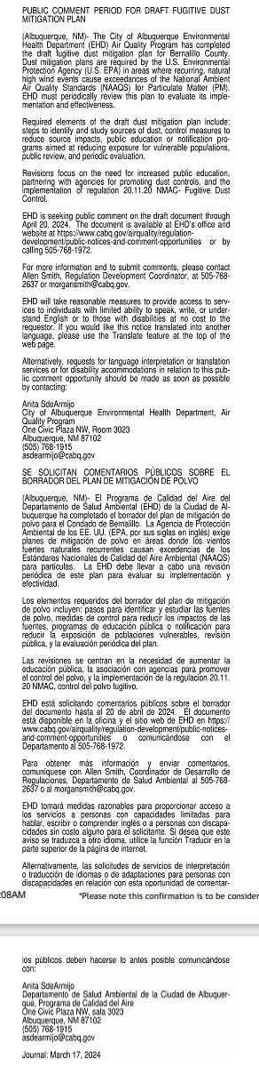

Figure 10: Air Quality Program ListServ notice of draft mitigation plan

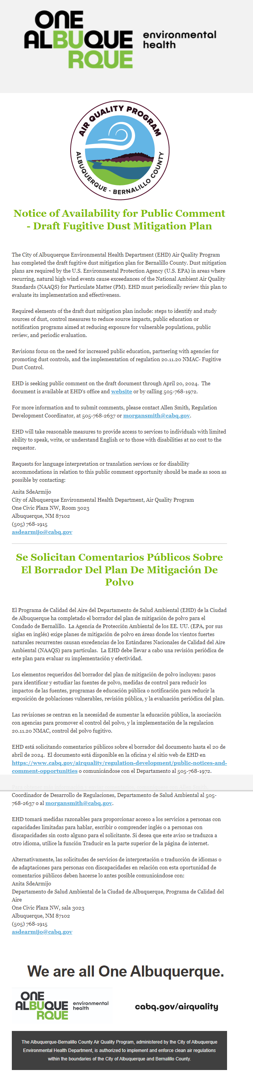

Figure 11: Air Quality Program website posting of draft mitigation plan

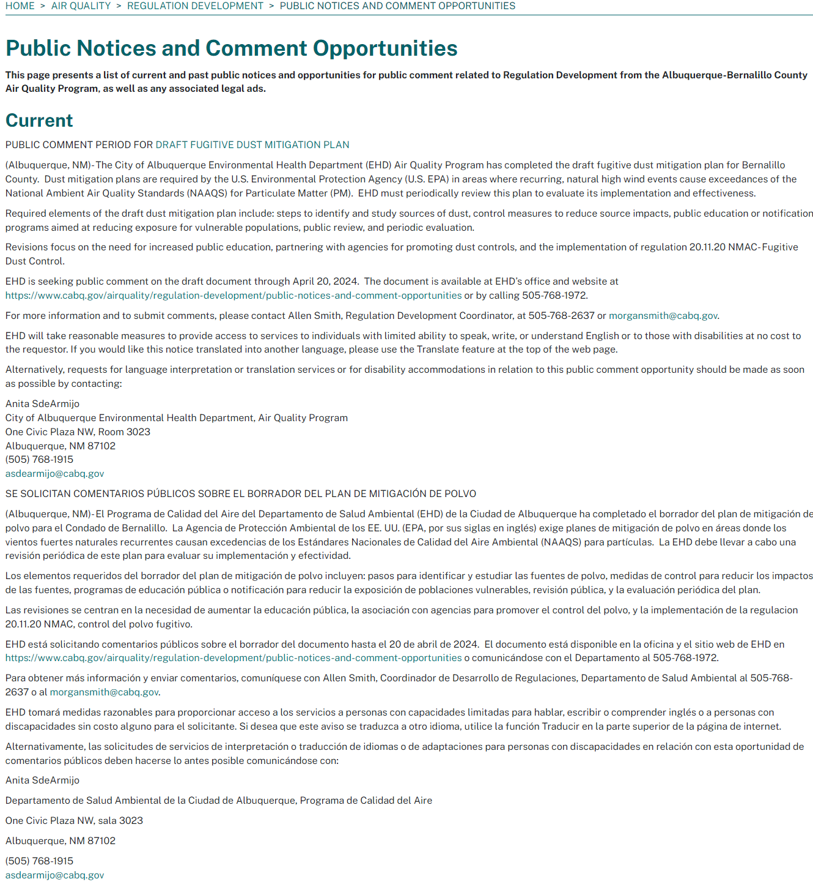

Submission of Mitigation Plans

Pursuant to 40 CFR 51.930, EHD submitted the plan on April 26, 2024 after a formal 30-day public comment period. This plan is not required to be part of EHD’s State Implementation Plan (SIP).

1. https://www.britannica.com/place/Albuquerque
2. Id.
3. Id.
4. Id.
5. https://www.env.nm.gov/air-quality/my-air-quality/
6. Id.
7. Kelley, Mary et al., *Analyzing two decades of dust events on the Southern Great Plains region of West Texas*, 2021 (pg. 2)
8. Id.
9. Id.
10. https://www.cabq.gov/airquality/air-quality-monitoring/trends/health-alert-information#shutdown-notices
11. https://www.cabq.gov/environmentalhealth/news/city-launches-bilingual-opt-in-emergency-health-alert-notifications
12. https://nmdeptag.nmsu.edu/healthy-soil-program.html
13. Webb, Nicholas et al., *Standard Methods for Wind Erosion Research and Model Development*, 2019 (pg. 24)
14. Raymond, A. J., Purdy, C., Fox, T., Kendall, A., DeJong, J. T., Kavazanjian Jr, E., ... & Martin, K. (2019). Life cycle sustainability assessment of enzyme-induced carbonate precipitation (EICP) for fugitive dust control. Academic Journal of Civil Engineering, 37(2), 600-60.
15. https://eos.org/articles/biocrust-probiotics-can-aid-dryland-restoration-efforts
16. Id.
17. Dust Mitigation Handbook, *One Stop Guide to Dust Mitigation*; Natural Resources Conservation Service, United States Department of Agriculture (pg. 54).
18. Id.
19. https://www.koat.com/article/goat-grazing-a-unique-and-natural-approach-to-fire-prevention-in-albuquerques-bosque/46571130
20. https://www.cabq.gov/parksandrecreation/news/winter-work-in-bosque-begins