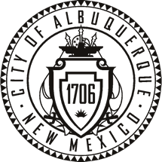
City of Albuquerque
Metro League Parents Code of Conduct

As parents and role models it’s important to help encourage and motivate young athletes by setting a good example. We live in a civil society where respect, maturity and effective communication can influence young athletes to grow into well rounded adults and parents. Please read over these rules and sign to help us maintain this status quo.

- I will remember that children participate to have fun and that the game is for youth, not adults.

- I will inform the coach of any physical disability or ailment that may affect the safety
of my child or the safety of others.

- I will learn the rules of the game and the policies of the league. I will also follow the
rules of any of the facilities my child’s team may visit for swim meets or water polo.

4. I will make sure my child is eligible in age and experience before committing to the
City of Albuquerque Metro League. This means that they have not participated with any club teams before March 31st 2014.

5. I (and my guests) will not engage in any kind of unsportsmanlike conduct with any
official, coach, player, or parent such as booing and taunting; refusing to shake hands;
or using profane language or gestures.

6. I will not encourage any behaviors or practices that would endanger the health and
well being of the athletes.

- I will refrain from coaching my child or other players during games and practices.
Any concerns will be brought up with the swim coach at a reasonable, convenient time.

8. I will promote the emotional and physical well being of the athletes ahead of any
personal desire I may have for my child to win.

Childs name (print) _____________________________________

Parent’s Signature / date _____________________________________

